Ellipsoid
# Source: AI Source: Provided by: [Data Path: Persons Table -> ID Column: 1, Name_En Column: Motasem Essam] -> From: [ChatGPT] on [7/25/2026]
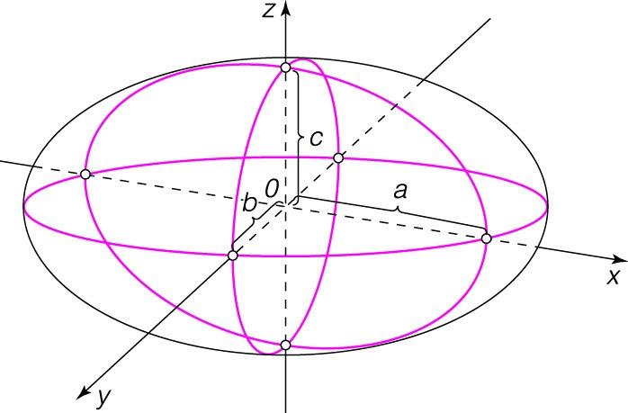
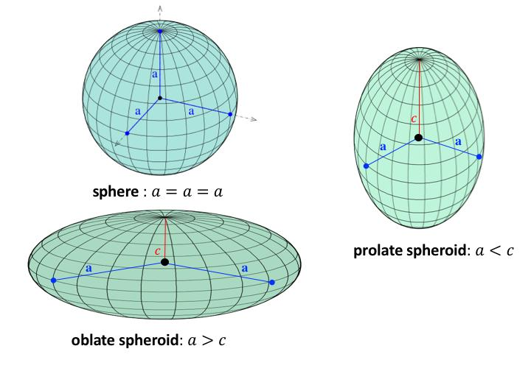
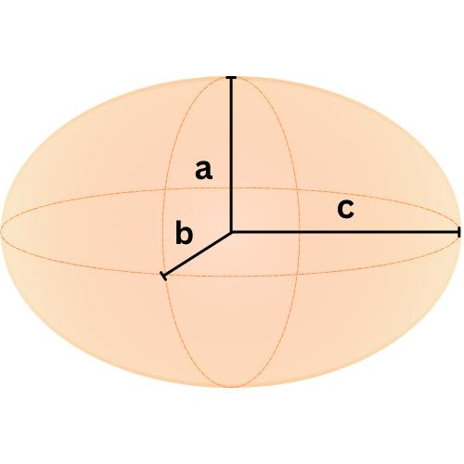

Definition
# Source: AI Source: Provided by: [Data Path: Persons Table -> ID Column: 1, Name_En Column: Motasem Essam] -> From: [ChatGPT] on [7/25/2026]
An ellipsoid is a three-dimensional geometric solid bounded by a closed curved surface. It resembles a sphere that has been stretched or compressed along one or more of its principal axes.
A sphere is a special case of an ellipsoid in which all three principal axes have equal lengths.
An ellipsoid is commonly described by three positive semi-axis lengths:
- $a$: semi-axis along the $x$-axis.
- $b$: semi-axis along the $y$-axis.
- $c$: semi-axis along the $z$-axis.

Simple Definition
# Source: AI Source: Provided by: [Data Path: Persons Table -> ID Column: 1, Name_En Column: Motasem Essam] -> From: [ChatGPT] on [7/25/2026]
An ellipsoid is a solid shaped like a stretched or flattened sphere, such as an oval-shaped ball.

Key Characteristics
# Source: AI Source: Provided by: [Data Path: Persons Table -> ID Column: 1, Name_En Column: Motasem Essam] -> From: [ChatGPT] on [7/25/2026]
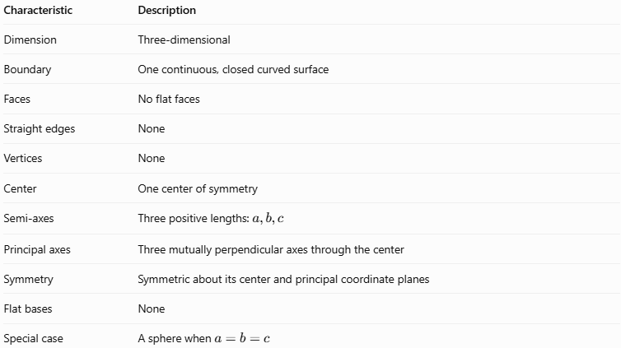
Characteristic | Description
Dimension | Three-dimensional
Boundary | One continuous, closed curved surface
Faces | No flat faces
Straight edges | None
Vertices | None
Center | One center of symmetry
Semi-axes | Three positive lengths: $a,b,c$
Principal axes | Three mutually perpendicular axes through the center
Symmetry | Symmetric about its center and principal coordinate planes
Flat bases | None
Special case | A sphere when $a=b=c$

Geometric Representation
# Source: AI Source: Provided by: [Data Path: Persons Table -> ID Column: 1, Name_En Column: Motasem Essam] -> From: [ChatGPT] on [7/25/2026]
An ellipsoid can be understood through its three principal dimensions:
- Semi-major axis: the longest semi-axis.
- Semi-minor axis: the shortest semi-axis.
- Intermediate semi-axis: the remaining semi-axis, when all three lengths differ.
The terms major and minor describe the longest and shortest dimensions, respectively. In a triaxial ellipsoid, the three semi-axes have different lengths.

Types by shape

Prolate ellipsoid
# Source: AI Source: Provided by: [Data Path: Persons Table -> ID Column: 1, Name_En Column: Motasem Essam] -> From: [ChatGPT] on [7/25/2026]
Elongated along one axis. For a prolate spheroid, two shorter semi-axes are equal.
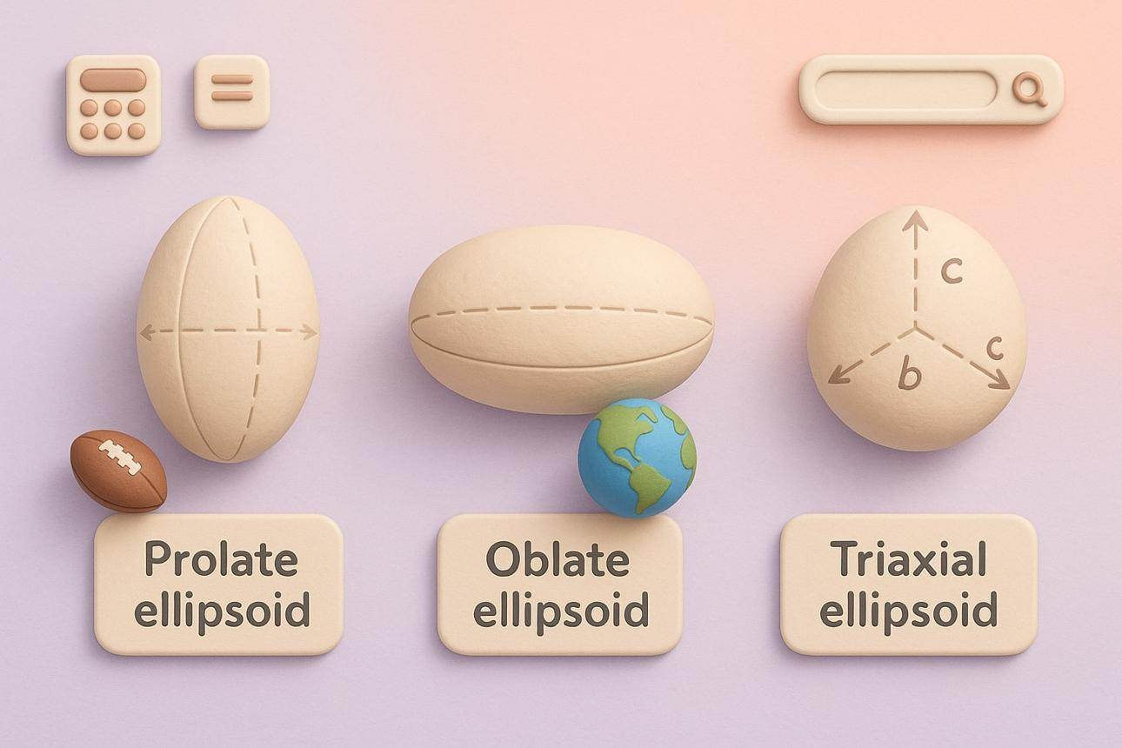

Oblate ellipsoid
# Source: AI Source: Provided by: [Data Path: Persons Table -> ID Column: 1, Name_En Column: Motasem Essam] -> From: [ChatGPT] on [7/25/2026]
Flattened along one axis. For an oblate spheroid, two longer semi-axes are equal.
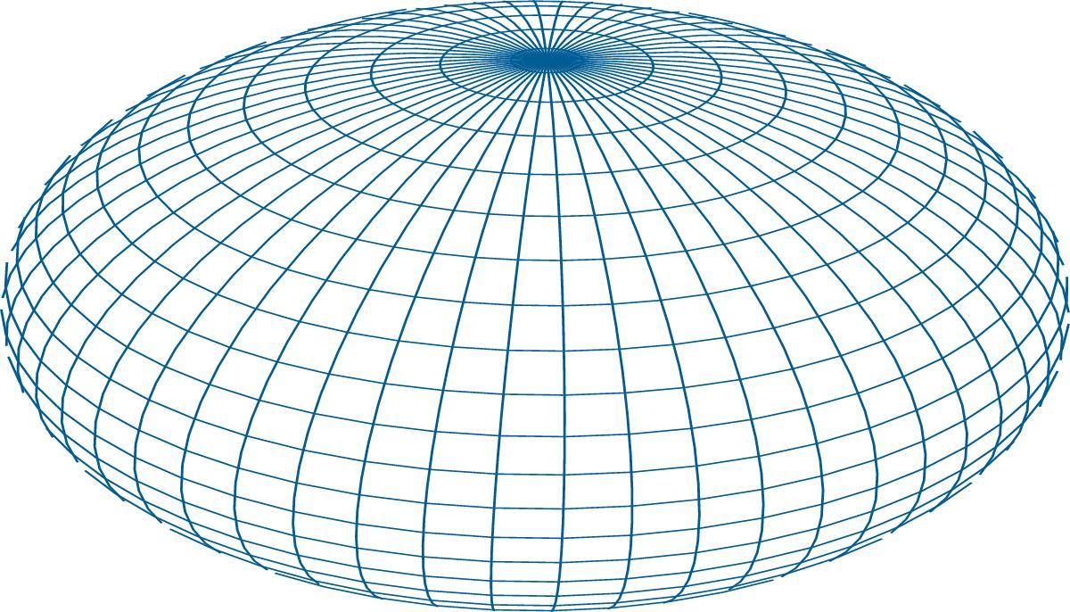

Triaxial ellipsoid
# Source: AI Source: Provided by: [Data Path: Persons Table -> ID Column: 1, Name_En Column: Motasem Essam] -> From: [ChatGPT] on [7/25/2026]
all three semi-axes are unequal, so $a≠b$, $b≠c$, and $a≠c$.
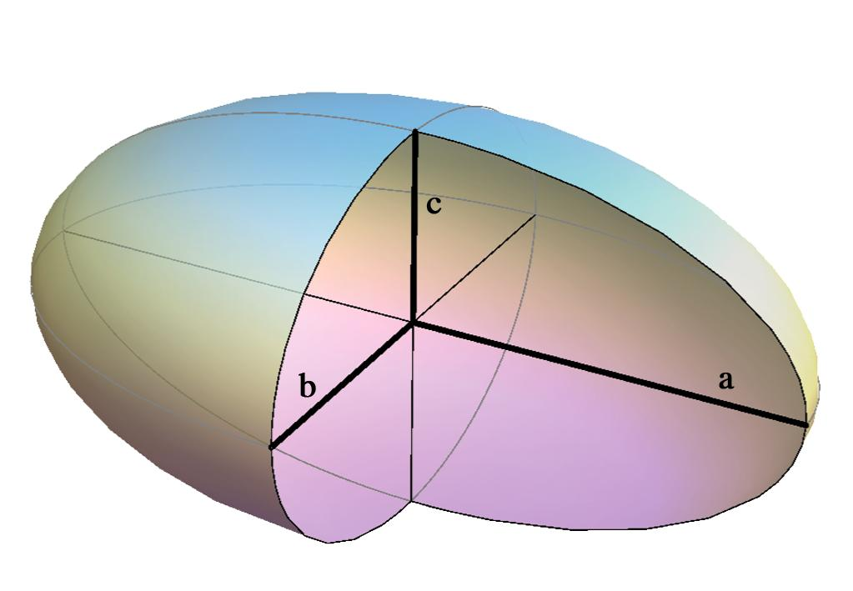

Mathematical Representations and Formulas

Standard Equation
# Source: AI Source: Provided by: [Data Path: Persons Table -> ID Column: 1, Name_En Column: Motasem Essam] -> From: [ChatGPT] on [7/25/2026]
An ellipsoid centered at the origin with its principal axes aligned with the coordinate axes is described by:
$$\frac{x^{2}}{a^{2}}+\frac{y^{2}}{b^{2}}+\frac{z^{2}}{c^{2}}=1$$
Where:
- $x,y,z$ are the coordinates of a point on the surface.
- $a,b,c$ are the semi-axis lengths.
- The center is $\left(0,0,0\right)$.
For points inside or on the solid, the equation becomes an inequality:
$$\frac{x^{2}}{a^{2}}+\frac{y^{2}}{b^{2}}+\frac{z^{2}}{c^{2}}≤1$$

Main Formulas
# Source: AI Source: Provided by: [Data Path: Persons Table -> ID Column: 1, Name_En Column: Motasem Essam] -> From: [ChatGPT] on [7/25/2026]
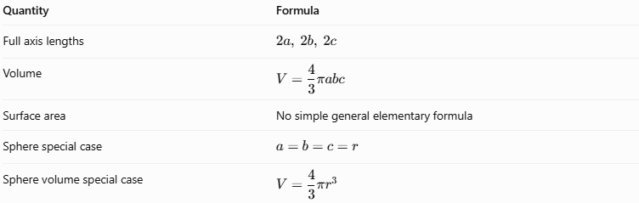
Quantity | Formula
Full axis lengths | $$2a, 2b, 2c$$
Volume | $$V=\frac{4}{3}πabc$$
Surface area | No simple general elementary formula
Sphere special case | $$a=b=c=r$$
Sphere volume special case | $$V=\frac{4}{3}{πr}^{3}$$
Important: The volume formula works for every ellipsoid. Its exact surface-area formula is more complicated and generally involves elliptic integrals. Approximation formulas are commonly used in practical calculations.

Approximate Surface Area
# Source: AI Source: Provided by: [Data Path: Persons Table -> ID Column: 1, Name_En Column: Motasem Essam] -> From: [ChatGPT] on [7/25/2026]
One widely used approximation is Knud Thomsen’s formula:
$$S≈4π{\left(\frac{{\left(ab\right)}^{p}+{\left(ac\right)}^{p}+{\left(bc\right)}^{p}}{3}\right)}^{1/p}$$
where $p≈1.6075$.
This formula is an approximation, not an exact identity. If $a=b=c=r$, it reduces to the exact sphere surface area $S=4πr^{2}$.

Worked Examples
# Source: AI Source: Provided by: [Data Path: Persons Table -> ID Column: 1, Name_En Column: Motasem Essam] -> From: [ChatGPT] on [7/25/2026]
Example 1: Calculate the Volume
An ellipsoid has semi-axes $a=6\text{ cm}$, $b=4\text{ cm}$, and $c=3\text{ cm}$. Find its volume.
Solution
$$V=\frac{4}{3}πabc$$
Substitute the values:
$$V=\frac{4}{3}π\left(6\right)\left(4\right)\left(3\right)$$
$$V=96π$$
$$\boxed{V≈301.59{\text{ cm}}^{3}}$$
Example 2: Find the Full Axis Lengths
An ellipsoid has semi-axes $a=5\text{ cm}$, $b=3\text{ cm}$, and $c=2\text{ cm}$.
The full axis lengths are twice their corresponding semi-axes:
$$2a=10\text{ cm}$$
$$2b=6\text{ cm}$$
$$2c=4\text{ cm}$$
Answer: The three full axis lengths are $10\text{ cm}$, $6\text{ cm}$, and $4\text{ cm}$.
Example 3: Determine Whether the Ellipsoid Is a Sphere
Suppose an ellipsoid has semi-axes $a=7$, $b=7$, and $c=7$.
Since
$$a=b=c=7$$
the ellipsoid is a sphere of radius $7$.
Its volume is:
$$V=\frac{4}{3}π{\left(7\right)}^{3}=\frac{1372}{3}π$$
$$\boxed{V≈1436.76\text{ cubic units}}$$
Example 4: Identify the Type
Classify an ellipsoid with semi-axes $a=8$, $b=5$, and $c=3$.
Because all three semi-axes have different lengths, the solid is a triaxial ellipsoid.

Constructing a Ellipsoid

Geometric Instruments
# Source: AI Source: Provided by: [Data Path: Persons Table -> ID Column: 1, Name_En Column: Motasem Essam] -> From: [ChatGPT] on [7/25/2026]
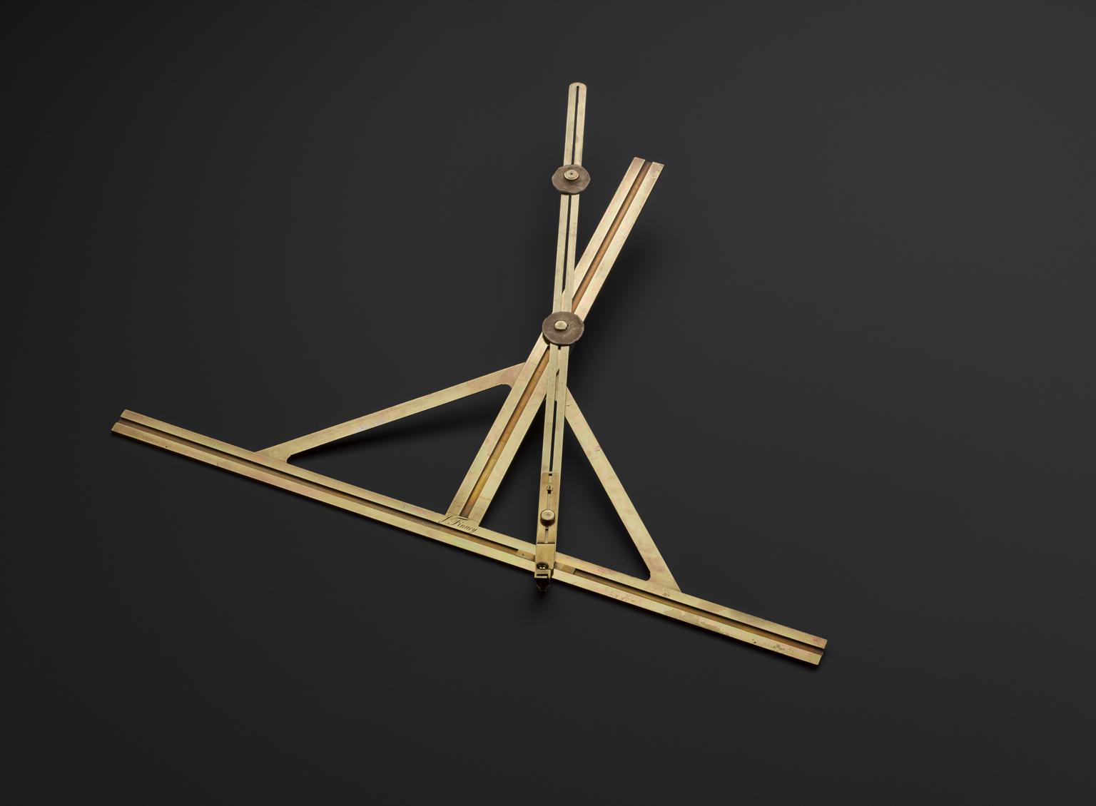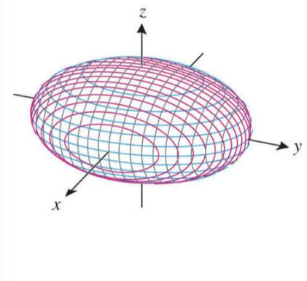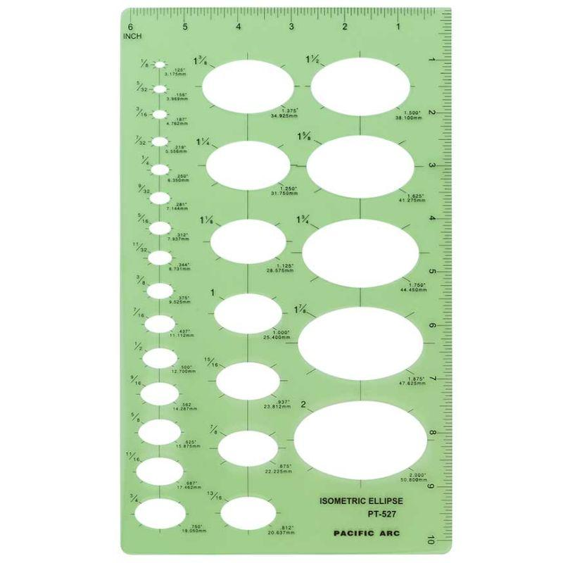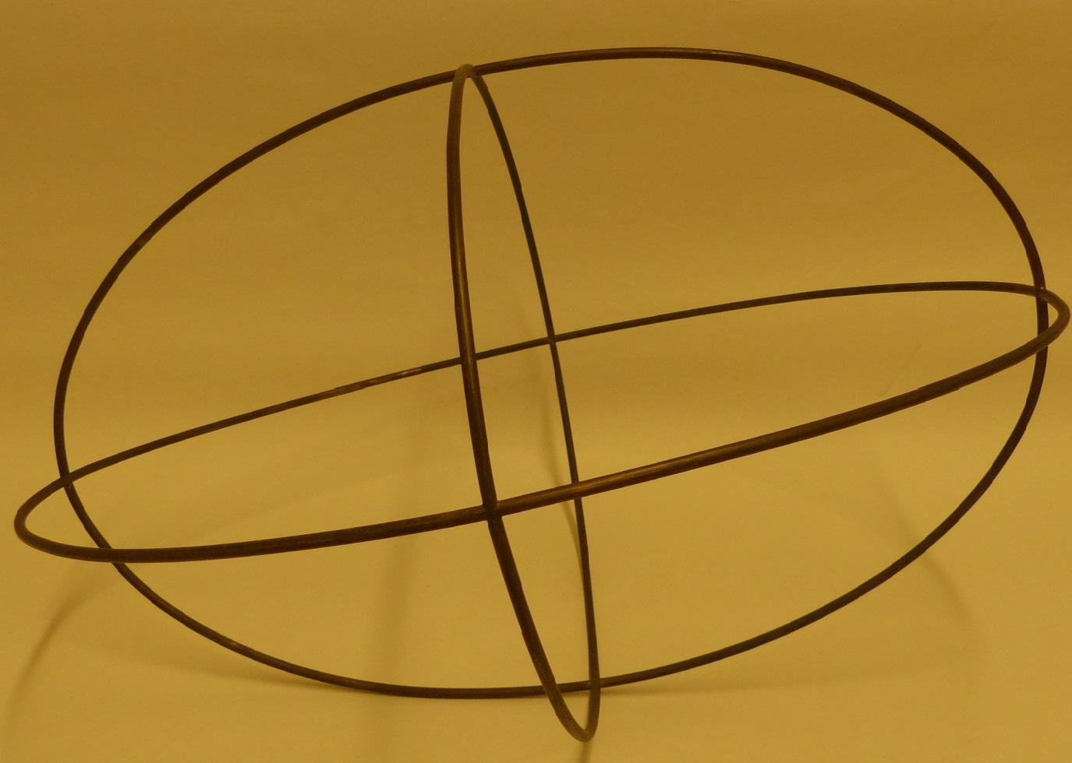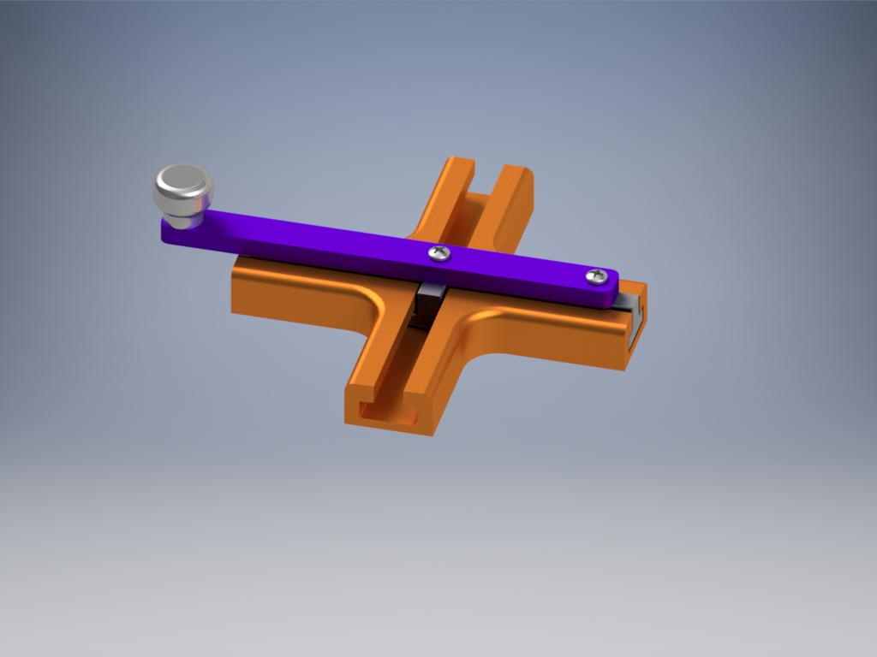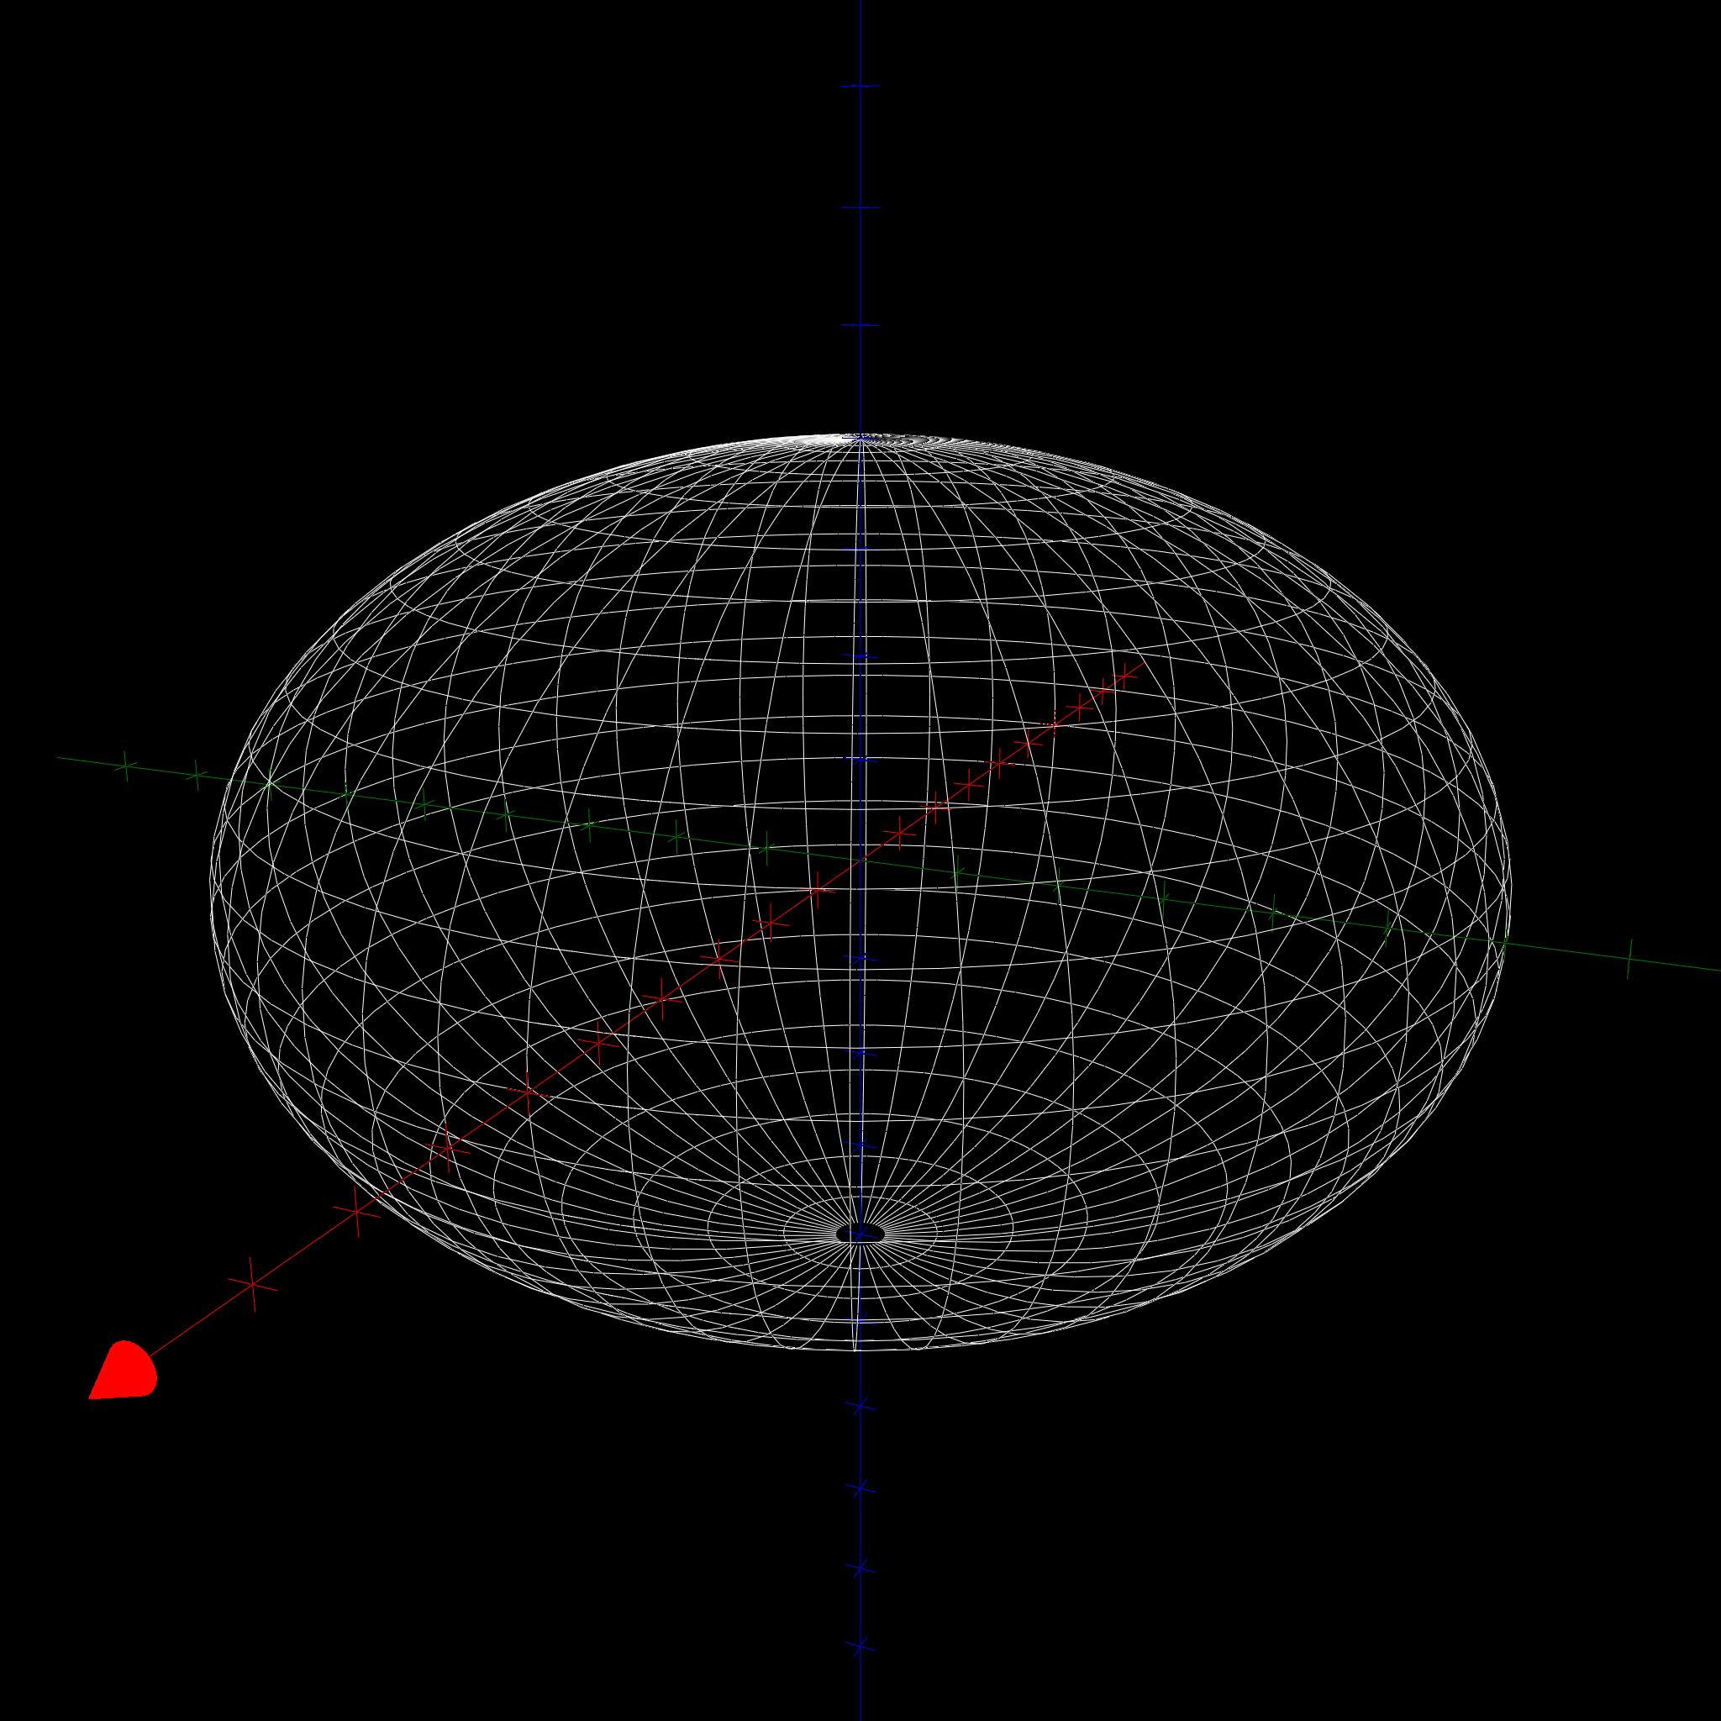
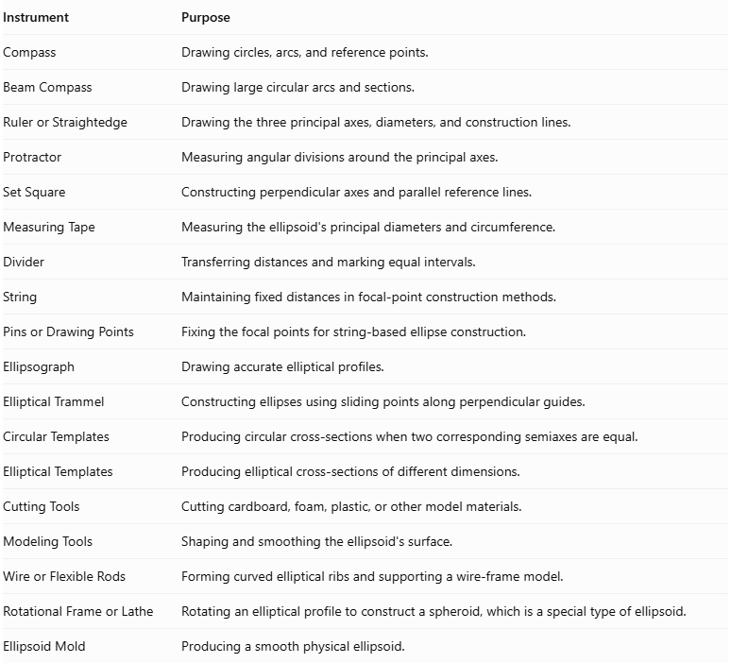
Instrument | Purpose
Compass | Drawing circles, arcs, and reference points.
Beam Compass | Drawing large circular arcs and sections.
Ruler or Straightedge | Drawing the three principal axes, diameters, and construction lines.
Protractor | Measuring angular divisions around the principal axes.
Set Square | Constructing perpendicular axes and parallel reference lines.
Measuring Tape | Measuring the ellipsoid's principal diameters and circumference.
Divider | Transferring distances and marking equal intervals.
String | Maintaining fixed distances in focal-point construction methods.
Pins or Drawing Points | Fixing the focal points for string-based ellipse construction.
Ellipsograph | Drawing accurate elliptical profiles.
Elliptical Trammel | Constructing ellipses using sliding points along perpendicular guides.
Circular Templates | Producing circular cross-sections when two corresponding semiaxes are equal.
Elliptical Templates | Producing elliptical cross-sections of different dimensions.
Cutting Tools | Cutting cardboard, foam, plastic, or other model materials.
Modeling Tools | Shaping and smoothing the ellipsoid's surface.
Wire or Flexible Rods | Forming curved elliptical ribs and supporting a wire-frame model.
Rotational Frame or Lathe | Rotating an elliptical profile to construct a spheroid, which is a special type of ellipsoid.
Ellipsoid Mold | Producing a smooth physical ellipsoid.

Instrument-Based Construction Procedures

Method 1: Constructing an Ellipsoid Using Three Principal Axes and Elliptical Profiles
# Source: AI Source: Provided by: [Data Path: Persons Table -> ID Column: 1, Name_En Column: Motasem Essam] -> From: [ChatGPT] on [7/25/2026]
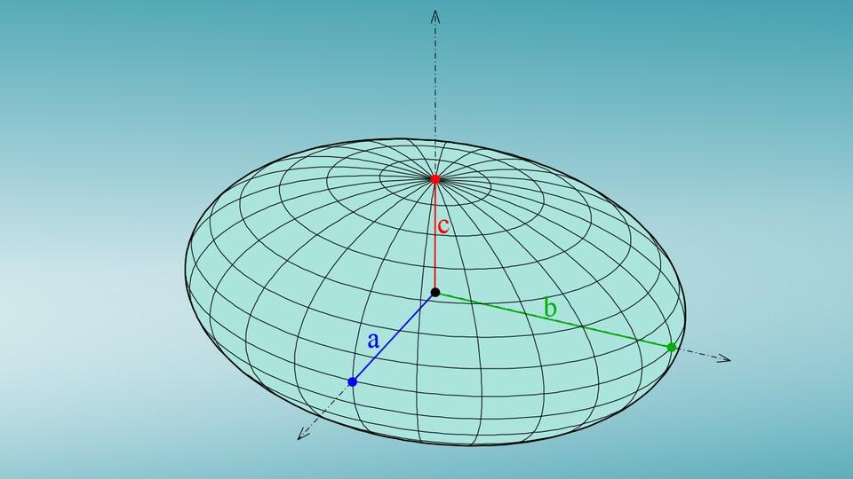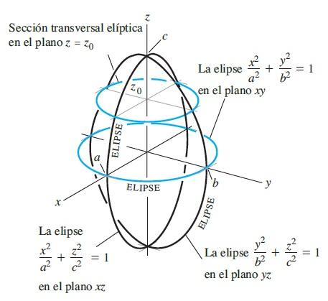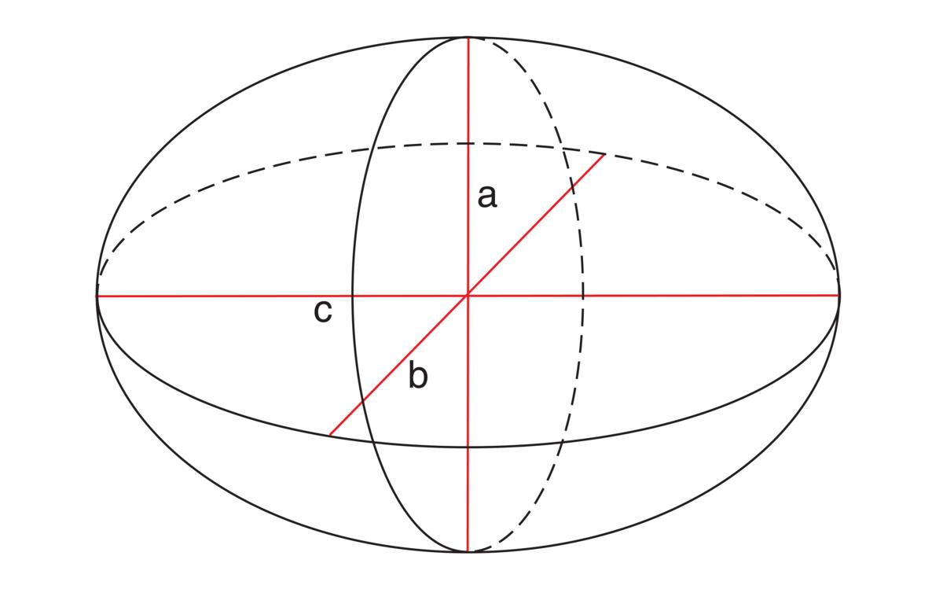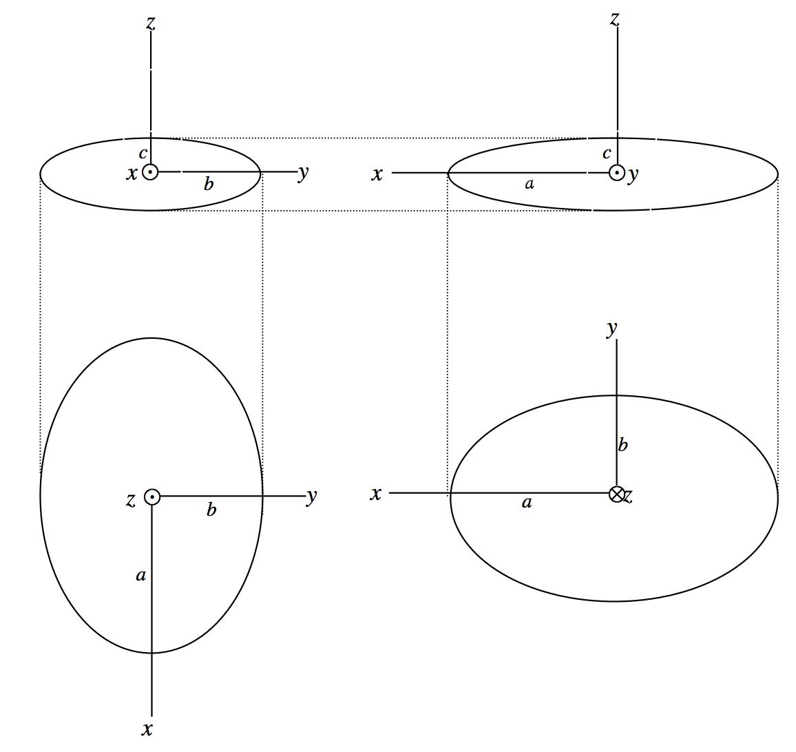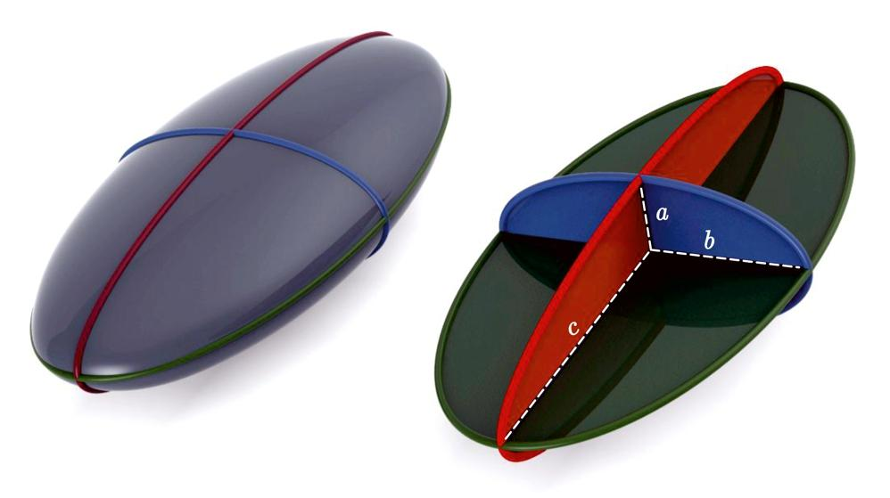
- Determine the required three semi-axis lengths:
- $a$: semi-major axis.
- $b$: second semi-axis.
- $c$: third semi-axis.
- Draw three mutually perpendicular axes intersecting at a common center.
- Mark the positive and negative endpoints of each axis using a ruler.
- Construct the first elliptical profile using the semi-axis lengths $a$ and $b$.
- Construct the second elliptical profile using $a$ and $c$.
- Construct the third elliptical profile using $b$ and $c$.
- Use an ellipsograph, elliptical trammel, or string-and-pins method to draw the profiles accurately.
- Cut the three profiles from cardboard, thin plastic, or another suitable material.
- Position the profiles perpendicular to their corresponding principal planes.
- Align all three profiles so their centers coincide.
- Join the profiles at their intersections using suitable supports.
- Add additional curved ribs or surface material to complete the three-dimensional ellipsoid.
- Smooth the surface and verify the three principal diameters.

Method 2: Constructing an Ellipsoid Using Elliptical Cross-Sections
# Source: AI Source: Provided by: [Data Path: Persons Table -> ID Column: 1, Name_En Column: Motasem Essam] -> From: [ChatGPT] on [7/25/2026]
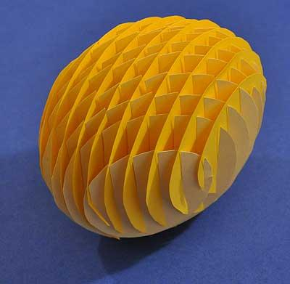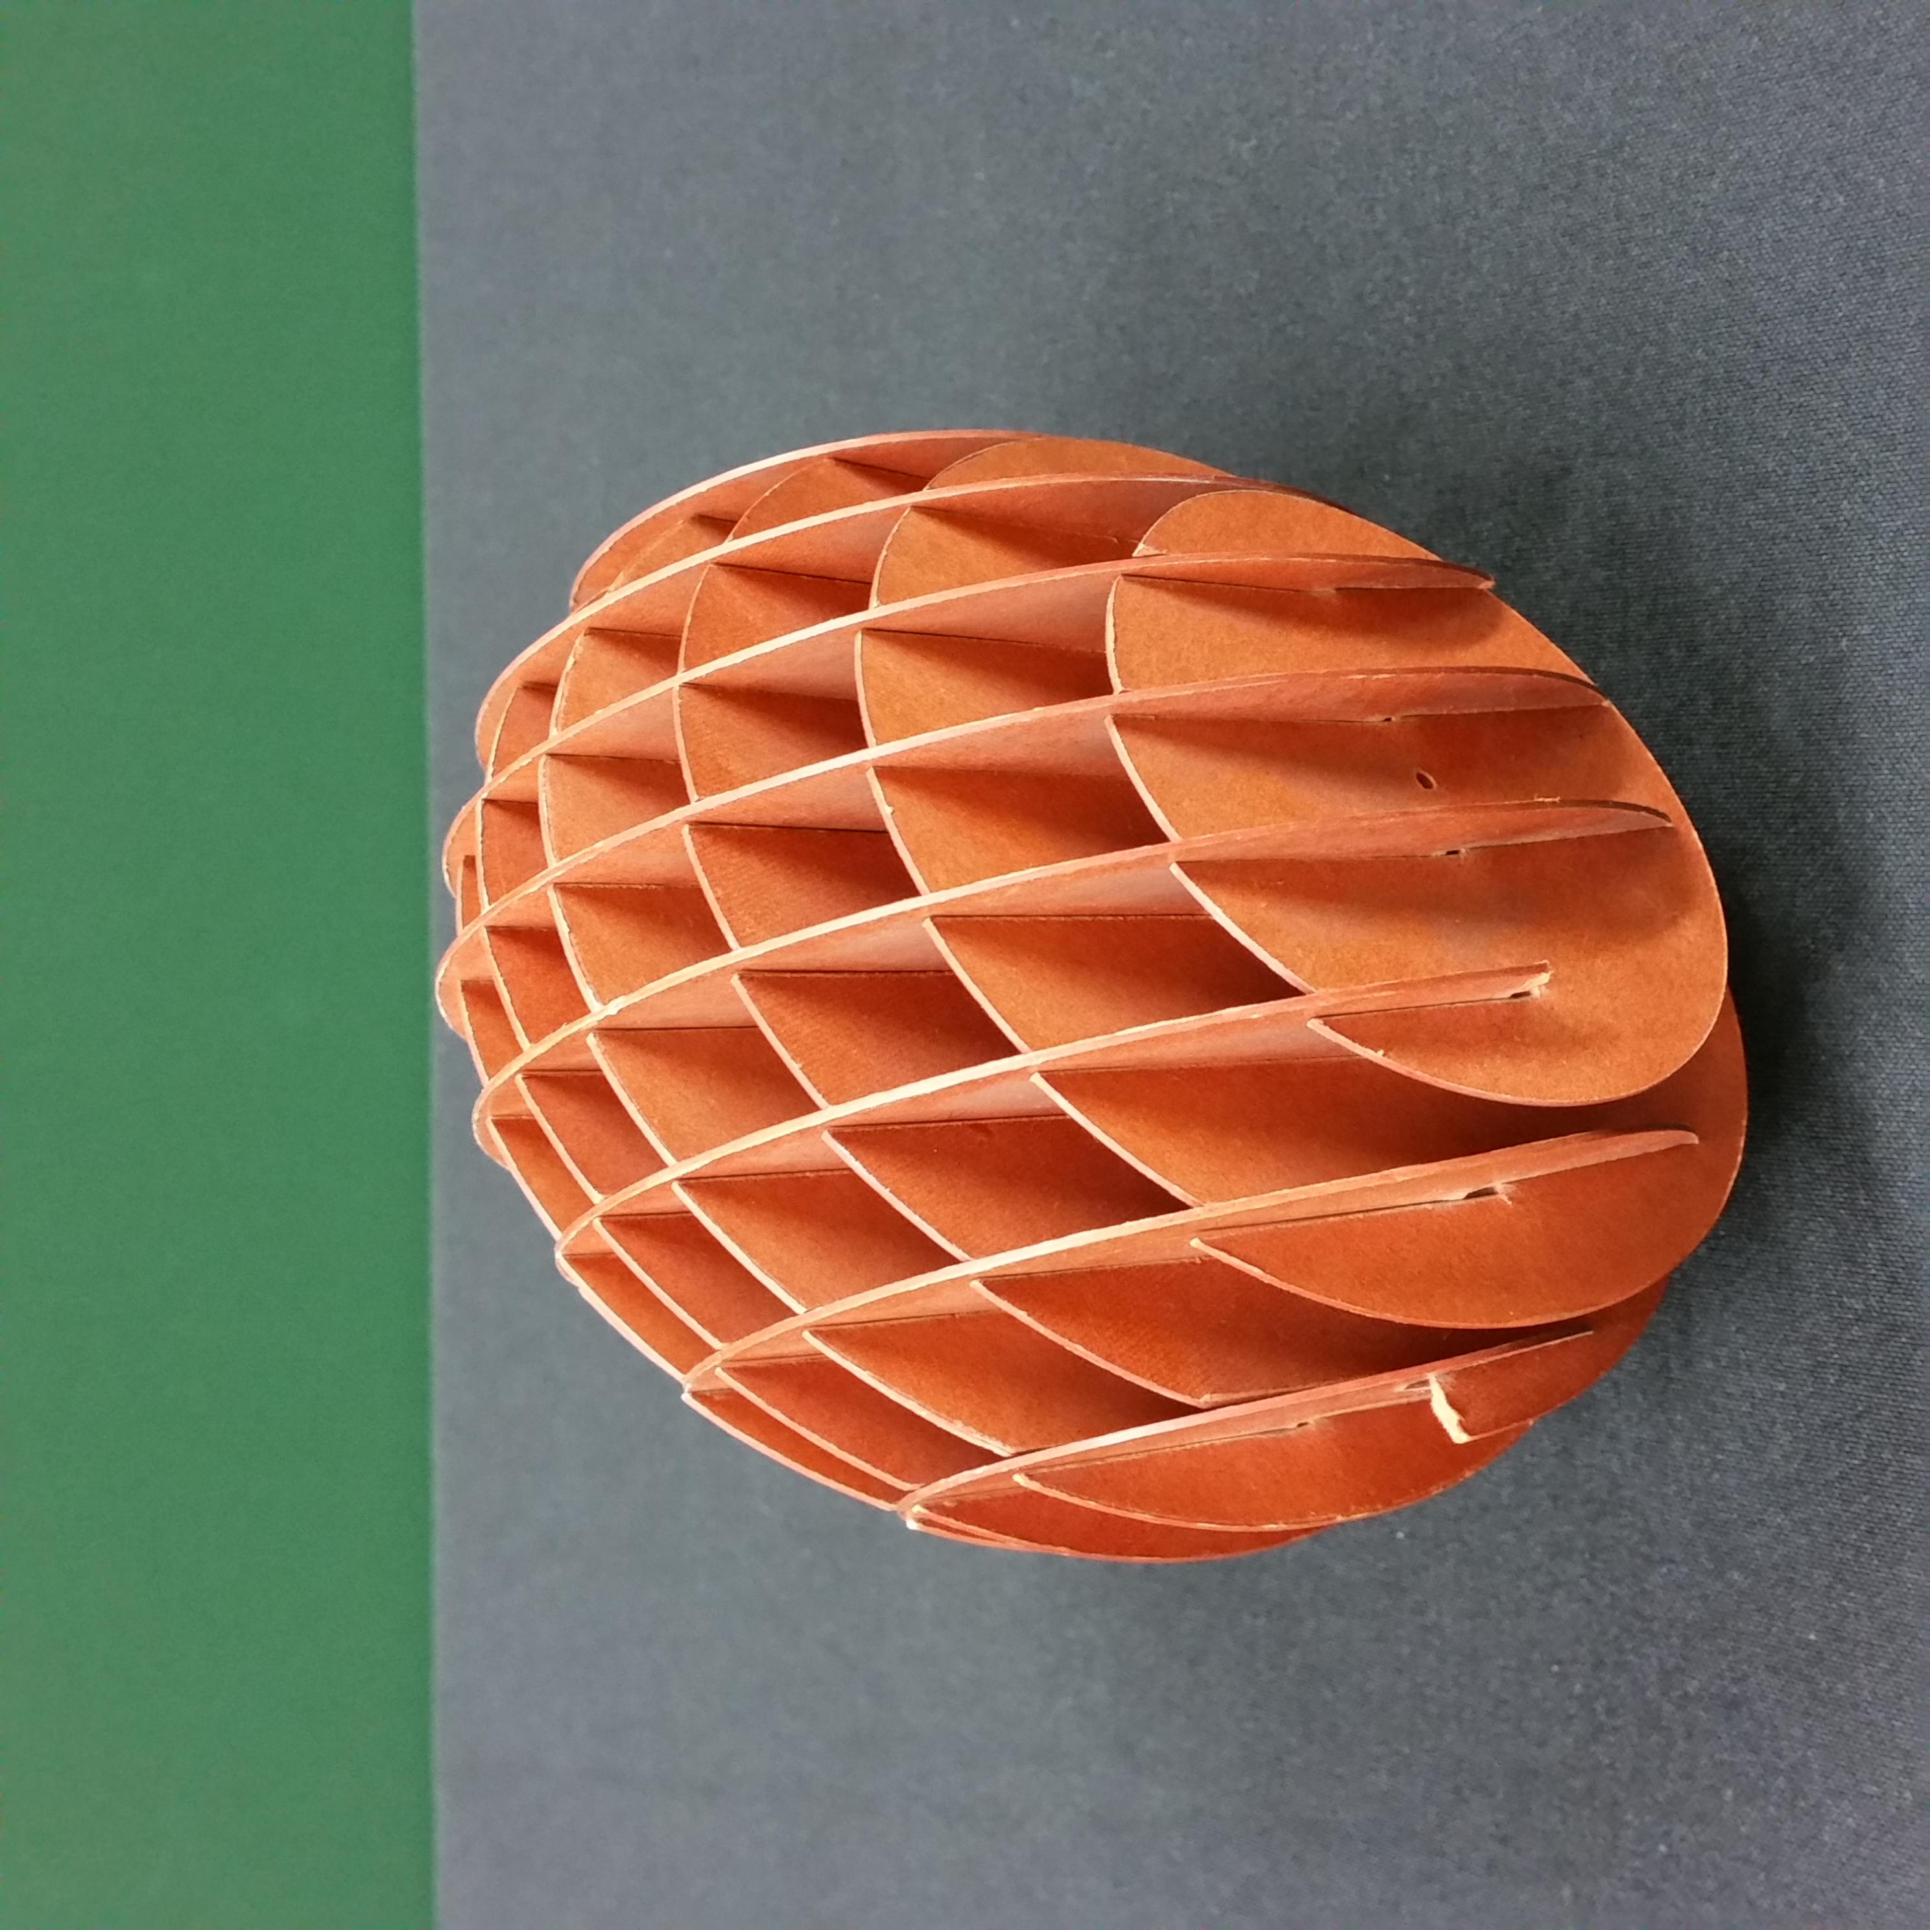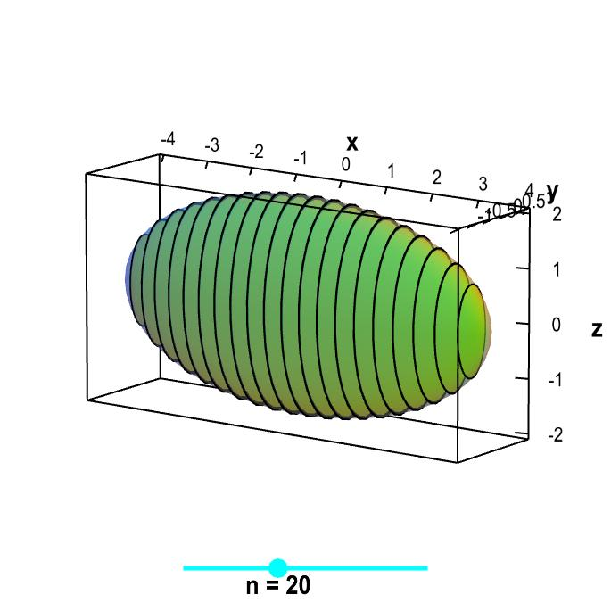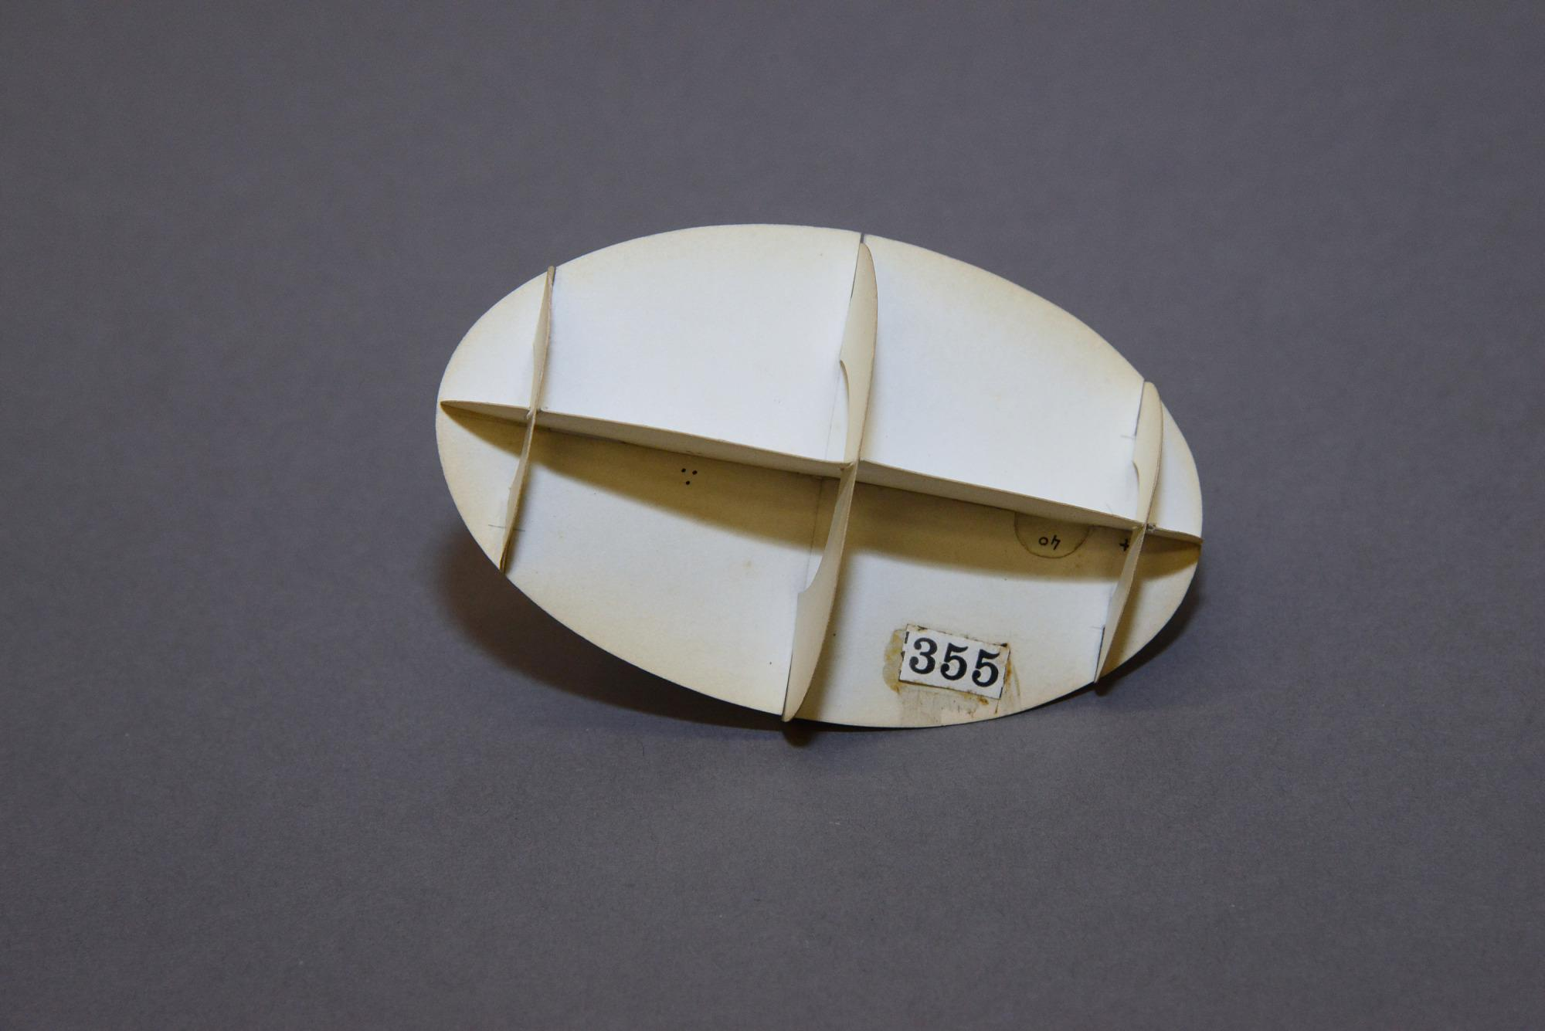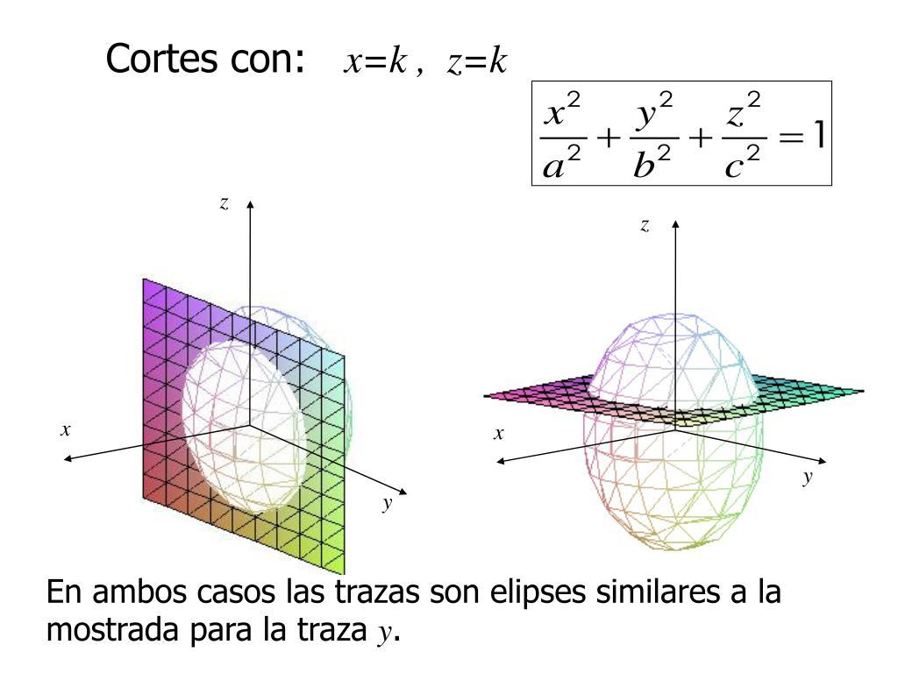
- Determine the semi-axis lengths $a$, $b$, and $c$.
- Draw the central axis corresponding to the semi-axis $c$.
- Mark the center and divide the axis into several equal intervals.
- Draw perpendicular reference lines through the division points using a set square.
- Determine the two semi-axis lengths of each elliptical cross-section.
- Construct each ellipse using an ellipsograph, elliptical trammel, or compass-based geometric construction.
- Draw the largest central section and progressively smaller sections toward both ends.
- Cut the elliptical sections from cardboard, foam, or another suitable material.
- Arrange the sections perpendicular to the central axis.
- Align their centers along the same axis.
- Join the sections using adhesive or a central support.
- Smooth the outer boundaries to approximate a continuous ellipsoid.
Note: These are elliptical sections, not necessarily circular sections. They become circles only when the two corresponding semi-axis lengths are equal.

Method 3: Constructing an Ellipsoid Using an Elliptical Trammel
# Source: AI Source: Provided by: [Data Path: Persons Table -> ID Column: 1, Name_En Column: Motasem Essam] -> From: [ChatGPT] on [7/25/2026]
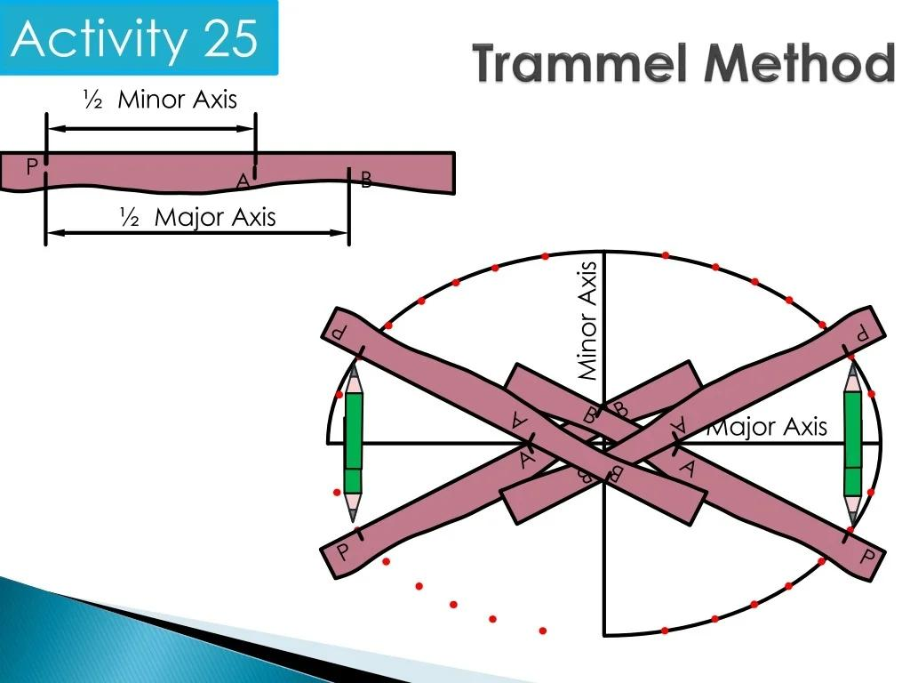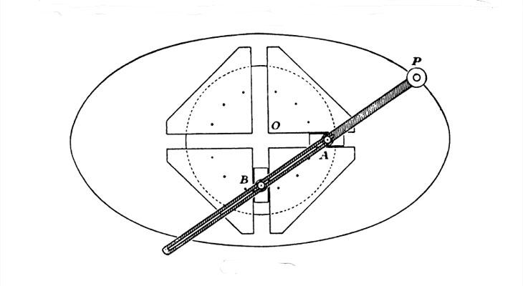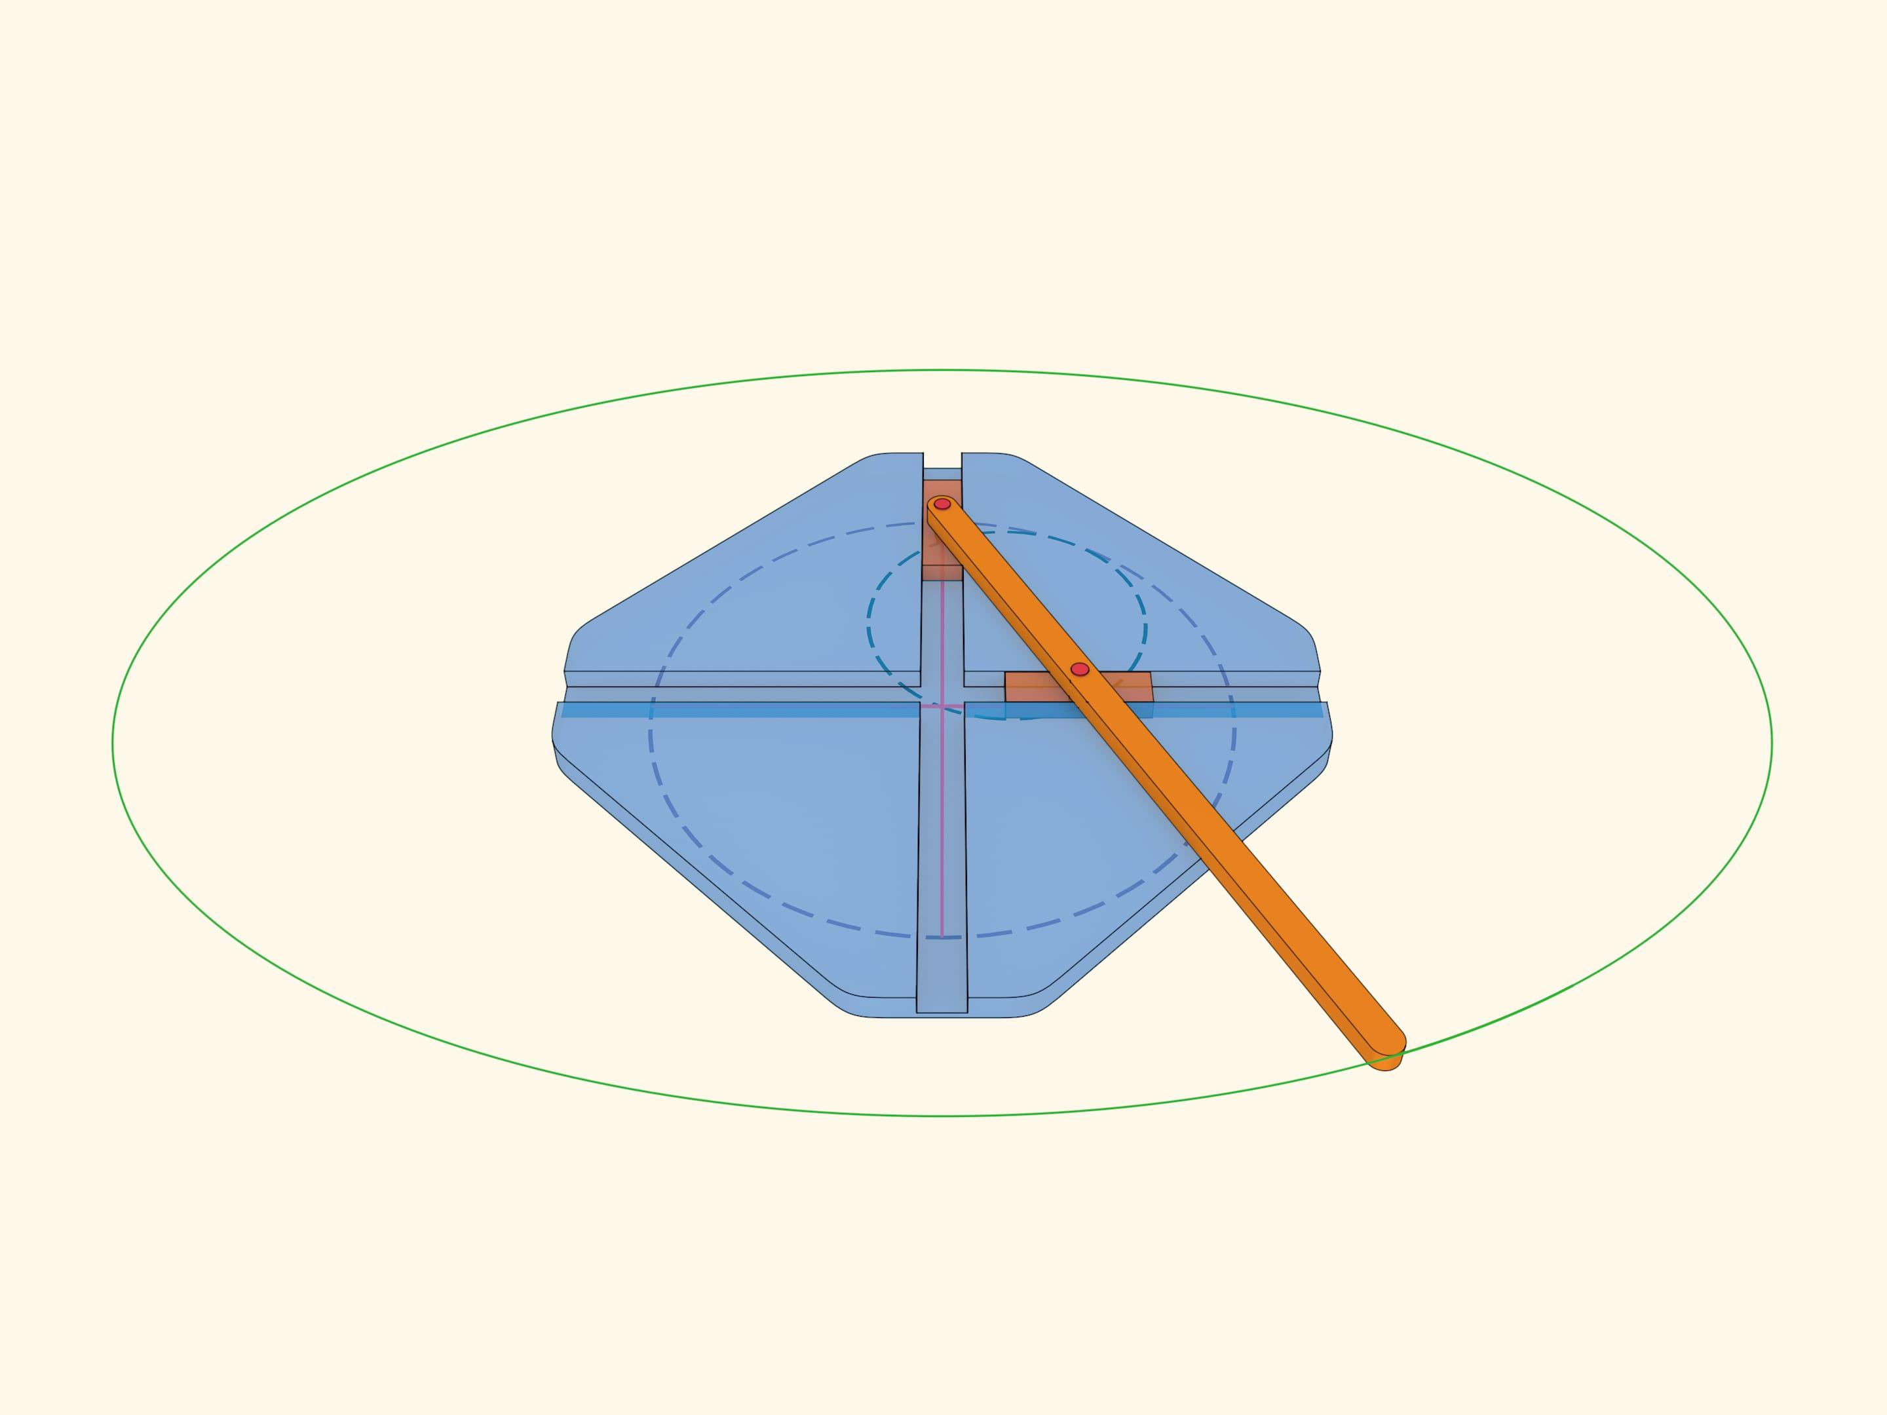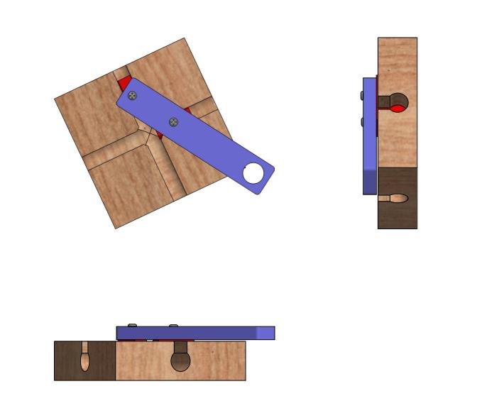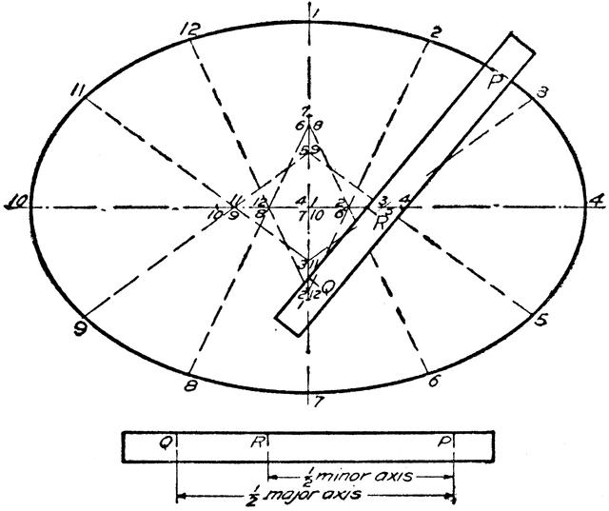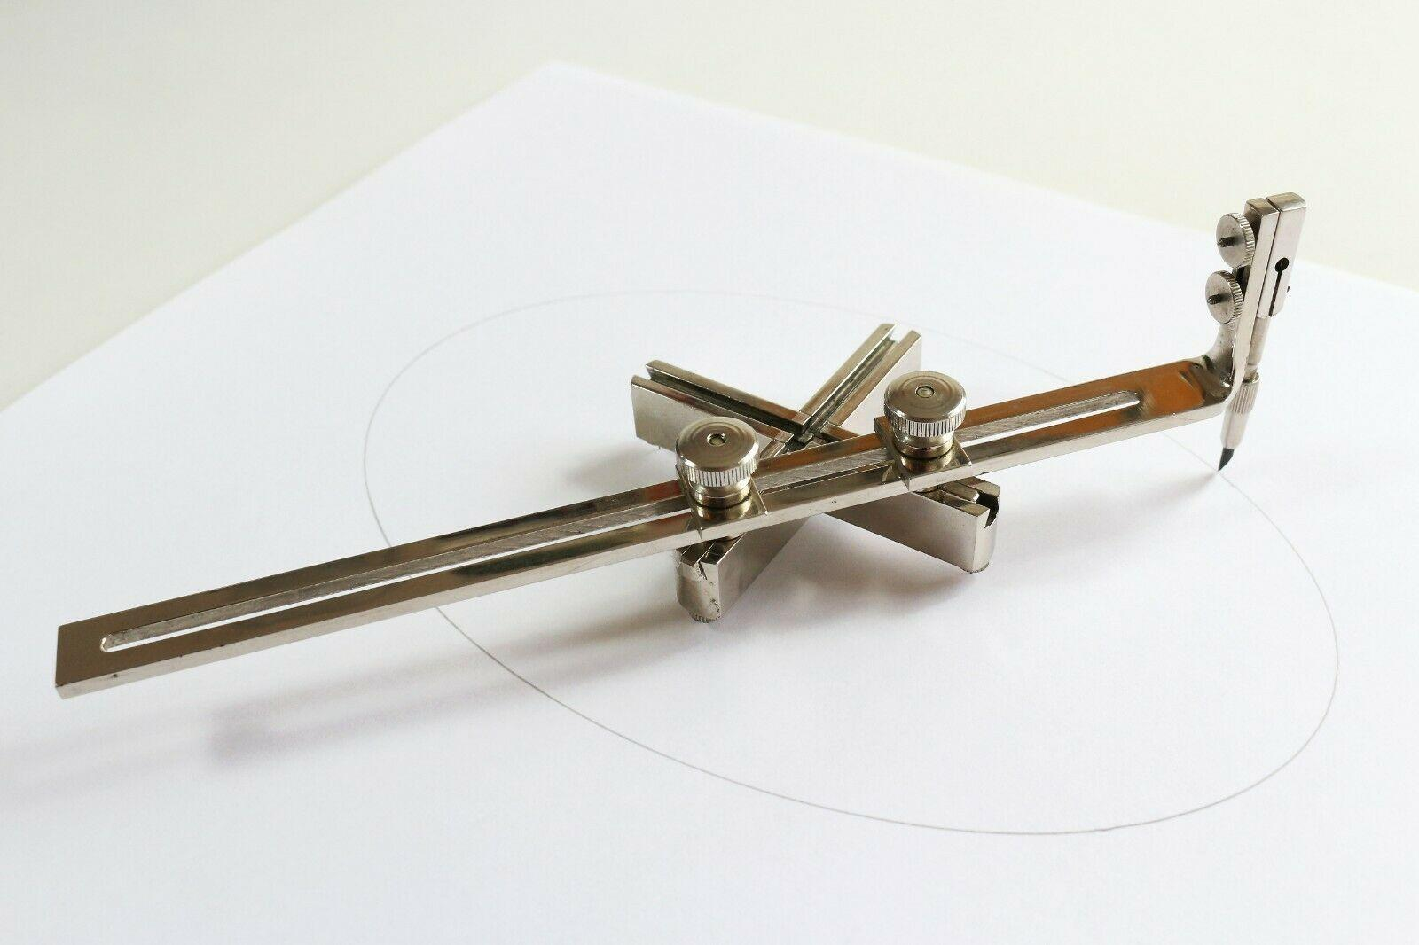
- Determine the required semi-major axis $a$ and semi-minor axis $b$ for the first elliptical profile.
- Draw two perpendicular reference axes intersecting at the center.
- Mark the endpoints of the required axes.
- Position the elliptical trammel so that its sliding guides follow the perpendicular axes.
- Adjust the sliding points according to the required axis lengths.
- Attach a pencil or tracing point to the designated drawing position.
- Move the trammel smoothly while keeping both sliding points on their respective guides.
- Trace the complete elliptical profile.
- Repeat the procedure for the other two principal elliptical profiles using the corresponding pairs of semi-axis lengths.
- Cut out the three elliptical profiles.
- Position them in their corresponding perpendicular planes.
- Join them at the common center and add supporting ribs or surface material to complete the ellipsoid.

Method 4: Constructing an Ellipsoid Using Pins and String
# Source: AI Source: Provided by: [Data Path: Persons Table -> ID Column: 1, Name_En Column: Motasem Essam] -> From: [ChatGPT] on [7/25/2026]
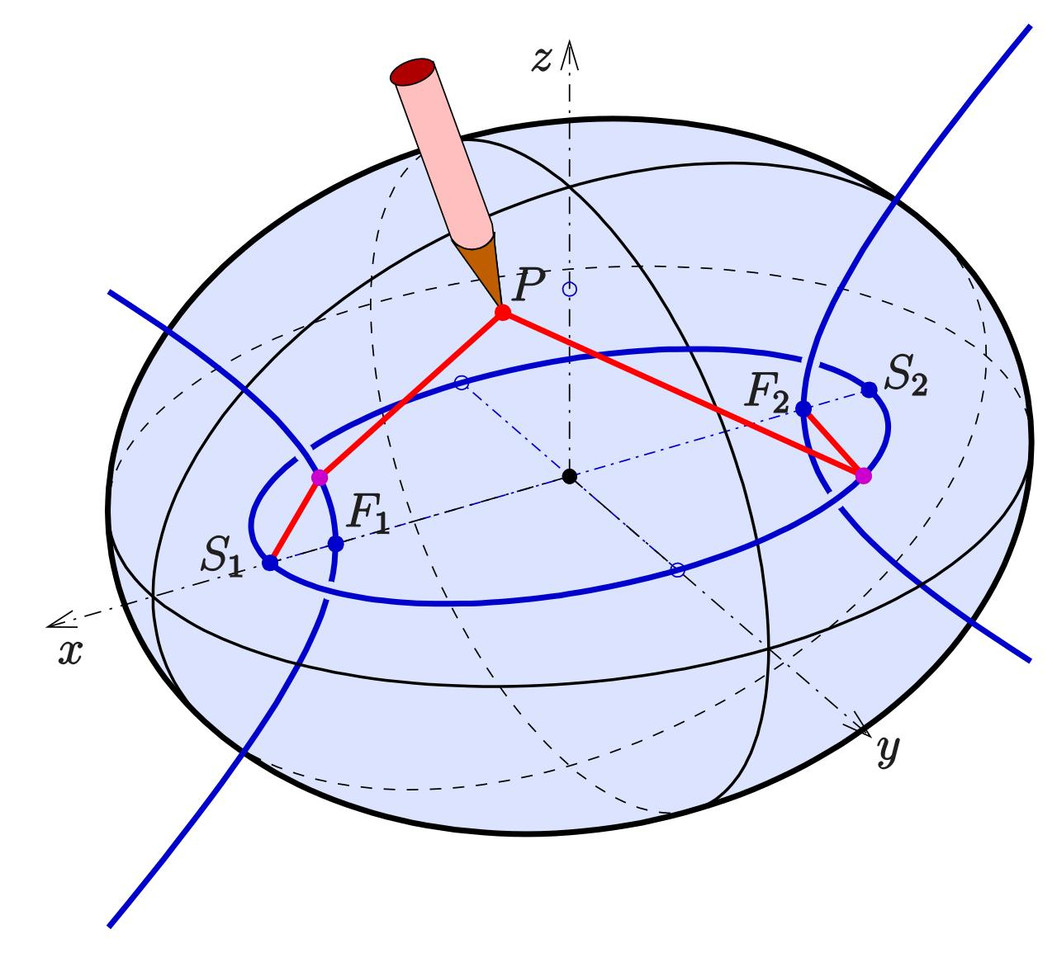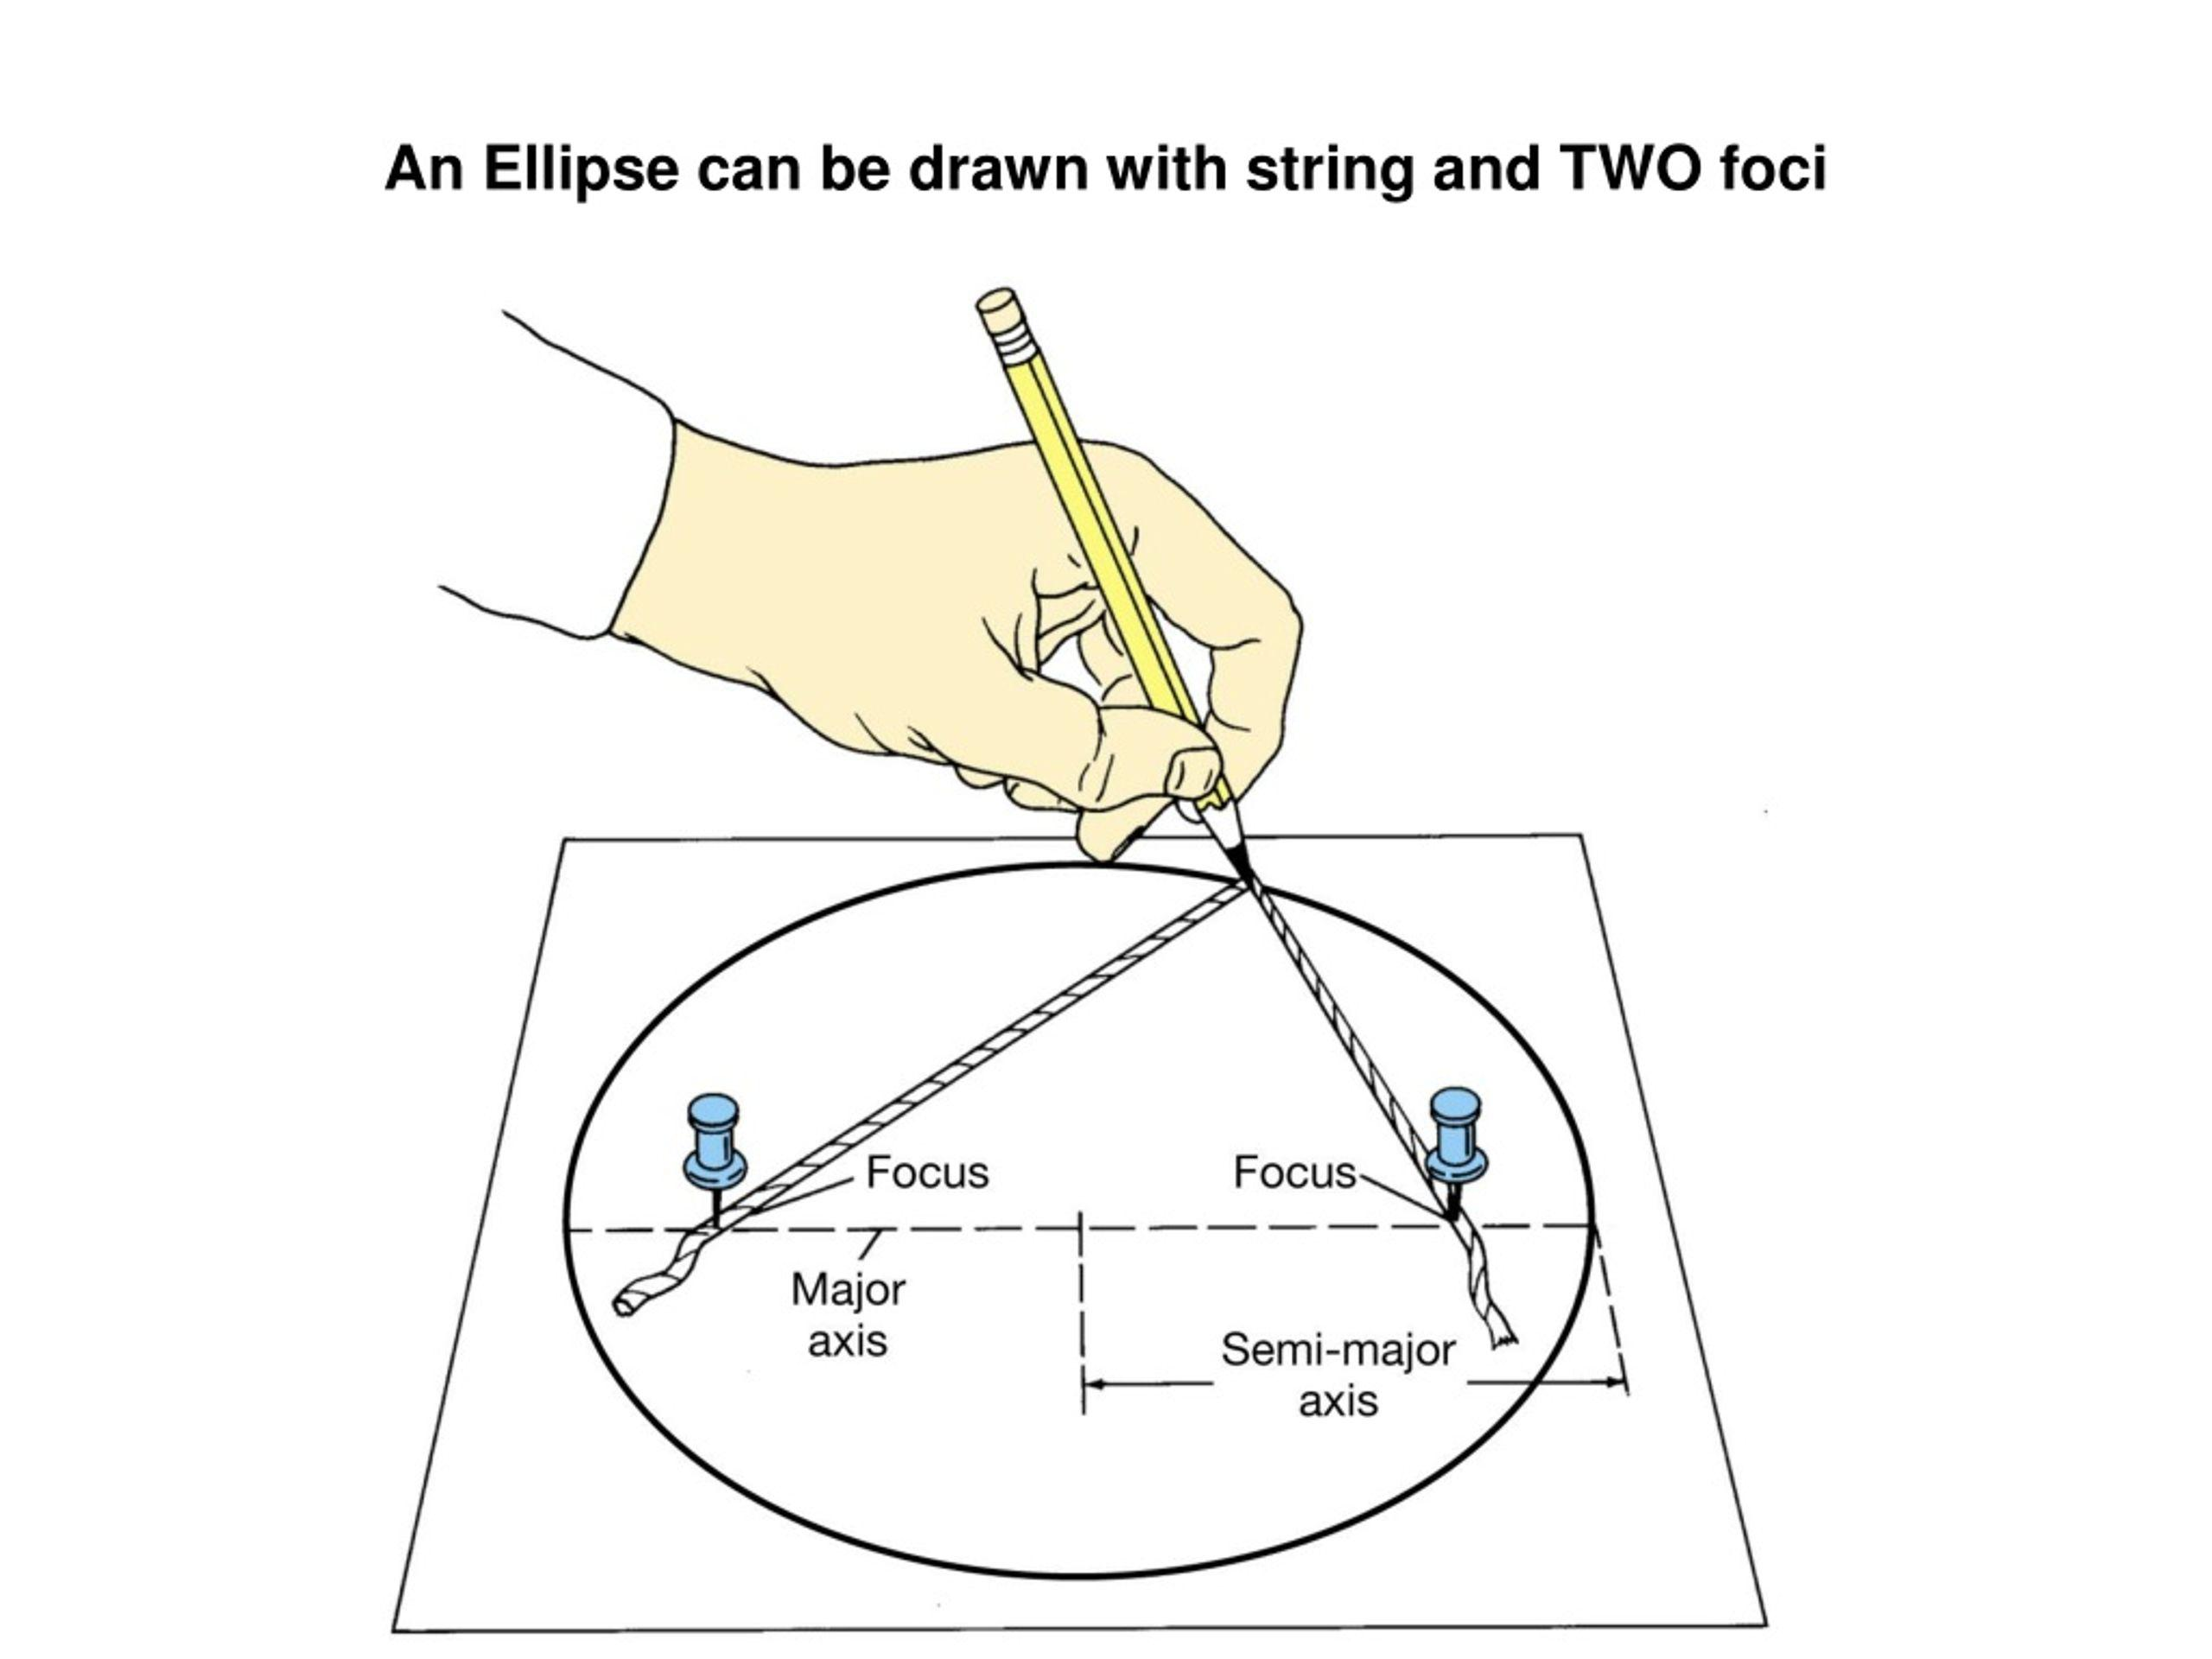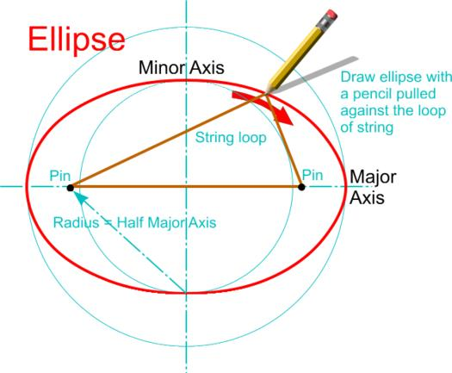
- Determine the required semi-major axis $a$ and semi-minor axis $b$ for the selected elliptical profile.
- Draw the major and minor axes perpendicular to each other.
- Mark the center of the ellipse.
- Determine the focal distance using:
$$f=\sqrt{a^{2}-b^{2}}$$
- Mark the two focal points symmetrically along the major axis.
- Fix a pin at each focal point.
- Attach a string between the pins, allowing enough length for the pencil to trace the ellipse.
- Place a pencil inside the string loop and pull it taut.
- Move the pencil around the focal points while maintaining string tension.
- Trace the complete elliptical profile.
- Repeat the procedure for the other principal elliptical profiles using their corresponding semi-axis lengths.
- Cut out and arrange the profiles in their perpendicular planes.
- Join the profiles and add supporting ribs or surface material to construct the ellipsoid.
Note: The string-and-pins method requires the major semi-axis to be at least as long as the minor semi-axis. The focal points must be repositioned for each different elliptical profile.

Method 5: Constructing an Ellipsoid Using Circular Cross-Section Families
# Source: AI Source: Provided by: [Data Path: Persons Table -> ID Column: 1, Name_En Column: Motasem Essam] -> From: [ChatGPT] on [7/25/2026]
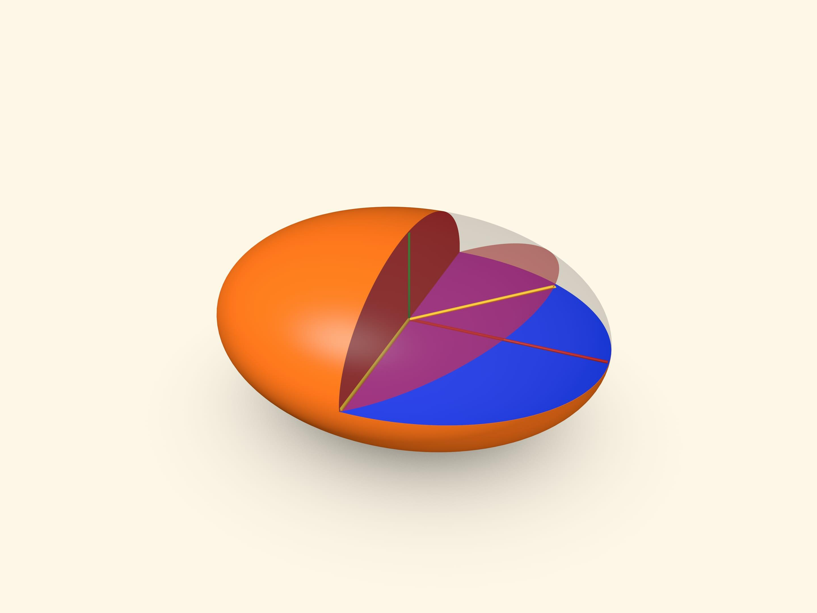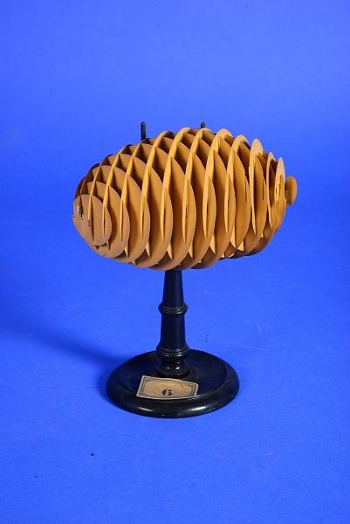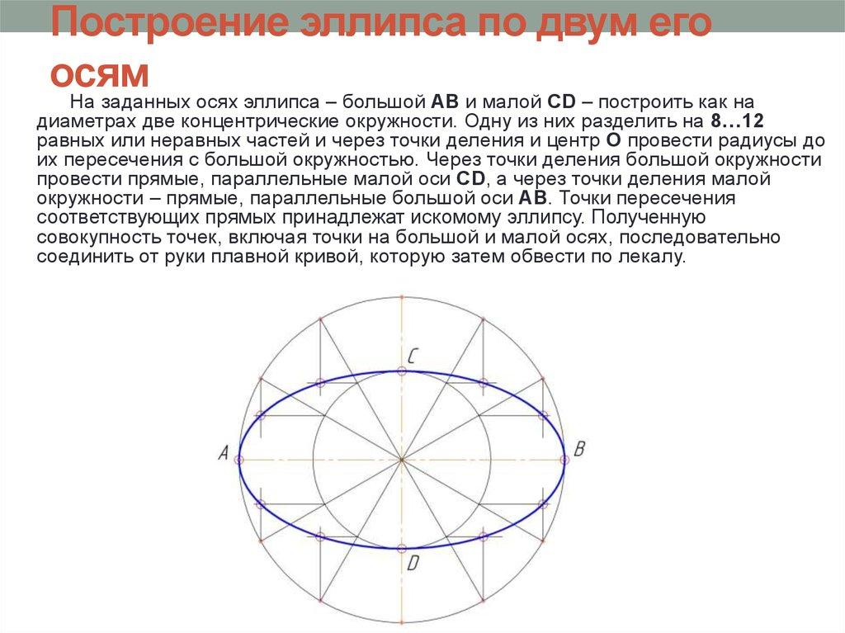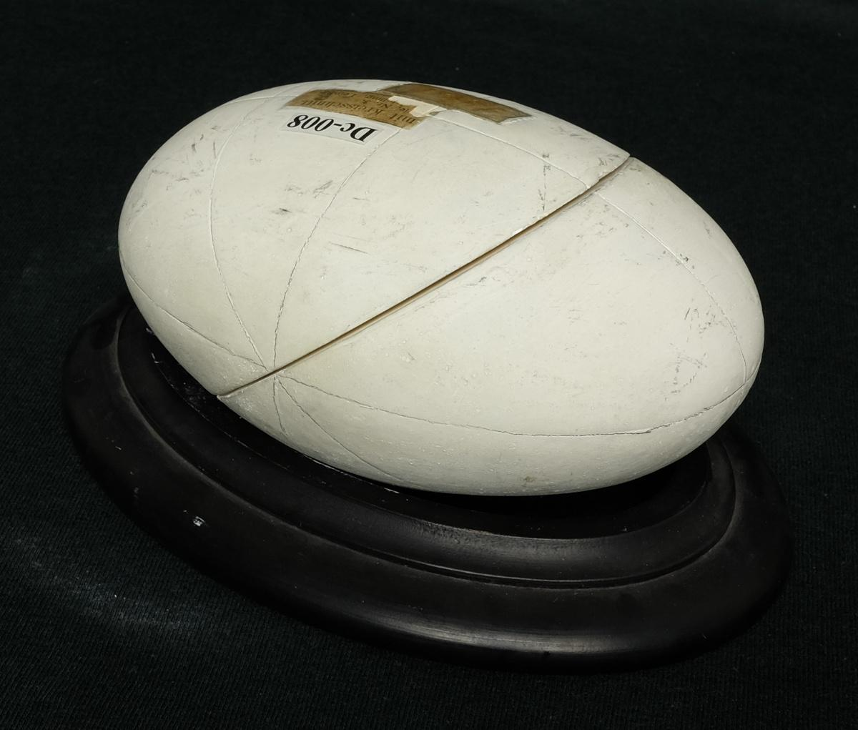
- Determine the three semi-axis lengths $a$, $b$, and $c$.
- Prepare two families of circular disks using accurately measured circular templates.
- Construct the first family of circular sections in one principal direction.
- Construct the second family in another principal direction.
- Determine the required circle sizes and positions from the ellipsoid's geometry.
- Cut suitable slots into the disks so that the two families can intersect and fit together.
- Assemble the disks through their corresponding slots.
- Adjust the disks so they can move or rotate without sliding out of their intended positions.
- Arrange the disks until their outer boundaries form the intended ellipsoidal shape.
- Secure the model if a fixed physical representation is required.
Note: This is a special geometric model of an ellipsoid using two families of circular sections. It is not the same as simply stacking circular disks along one axis.

Method 6: Constructing an Ellipsoid Using a Mold
# Source: AI Source: Provided by: [Data Path: Persons Table -> ID Column: 1, Name_En Column: Motasem Essam] -> From: [ChatGPT] on [7/25/2026]
- Determine the required three semi-axis lengths $a$, $b$, and $c$.
- Prepare a mold whose internal shape matches the intended ellipsoid.
- Verify the three principal diameters of the mold using measuring instruments.
- Align the mold sections along their corresponding principal planes.
- Secure the mold sections together.
- Prepare a suitable modeling material.
- Fill the mold with the material, ensuring that it occupies the intended ellipsoidal space.
- Allow the material to set or harden.
- Remove the mold, if it is designed to be removable.
- Smooth the joining boundaries and refine the surface.
- Measure the three principal diameters to verify the finished ellipsoid.

Method 7: Constructing an Ellipsoid Using a Wire-Frame Structure
# Source: AI Source: Provided by: [Data Path: Persons Table -> ID Column: 1, Name_En Column: Motasem Essam] -> From: [ChatGPT] on [7/25/2026]
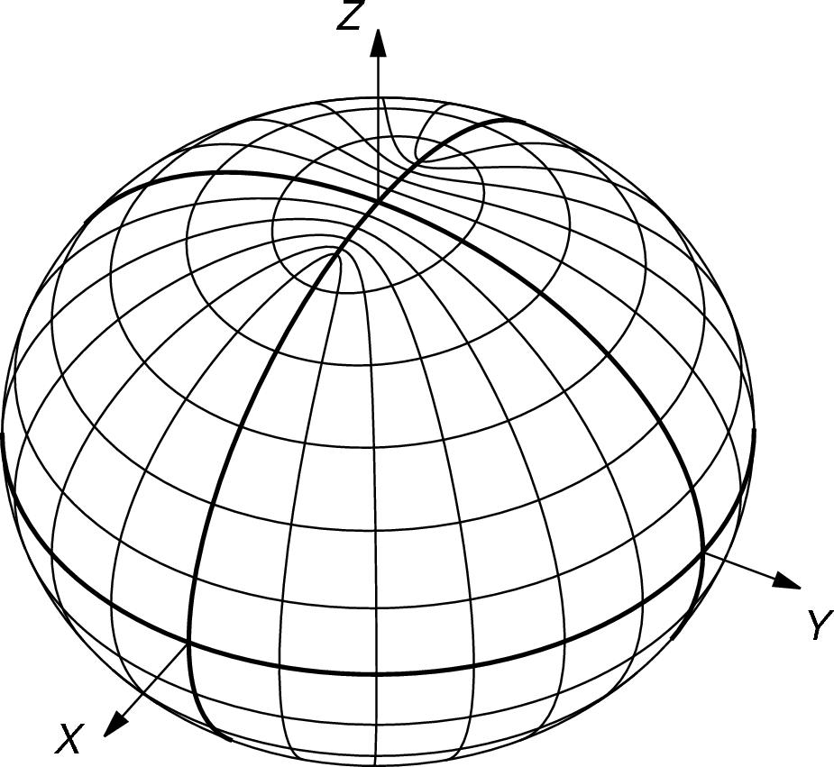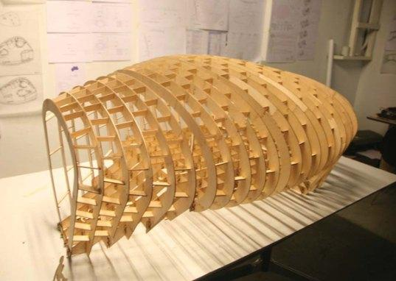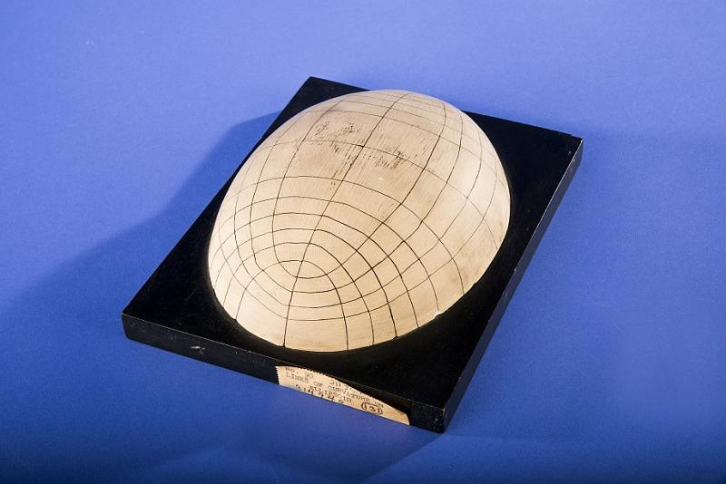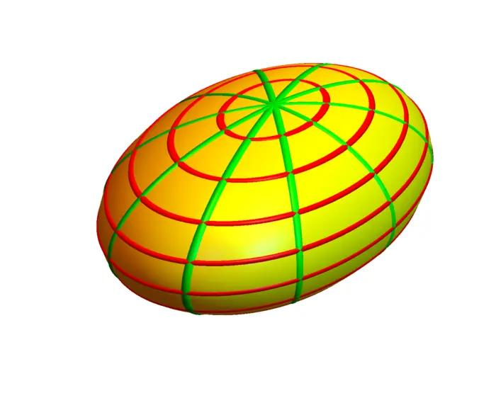
- Determine the three semi-axis lengths $a$, $b$, and $c$.
- Draw the three mutually perpendicular principal axes.
- Construct the three principal elliptical profiles.
- Cut or bend flexible wire according to the elliptical profiles.
- Position the first elliptical wire along the plane containing axes $a$ and $b$.
- Position the second elliptical wire along the plane containing axes $a$ and $c$.
- Position the third elliptical wire along the plane containing axes $b$ and $c$.
- Align the centers of all three profiles.
- Add additional curved wire ribs between the principal profiles to define the remaining surface.
- Connect the ribs at their intersection points using suitable fasteners or adhesive.
- Check the symmetry and principal dimensions.
- Cover the frame with a suitable flexible material if a solid surface is required.

Mathematical Reference for Cross-Section Construction
# Source: AI Source: Provided by: [Data Path: Persons Table -> ID Column: 1, Name_En Column: Motasem Essam] -> From: [ChatGPT] on [7/25/2026]
For an ellipsoid with semi-axis lengths $a$, $b$, and $c$, a cross-section perpendicular to the third principal axis, at distance $z$ from the center, is an ellipse with semi-axis lengths:
$$a_{z}=a\sqrt{1-\frac{z^{2}}{c^{2}}}$$
$$b_{z}=b\sqrt{1-\frac{z^{2}}{c^{2}}}$$
This applies for $-c≤z≤c$.
The corresponding circular cross-sections occur when the two semi-axis lengths of the section are equal.
Construction note: A general triaxial ellipsoid has three different semi-axis lengths. Rotating an elliptical profile around one of its axes produces a spheroid only when the other two semi-axes are equal. Therefore, rotational construction alone does not produce every type of ellipsoid.

Comparison with Related Solids
# Source: AI Source: Provided by: [Data Path: Persons Table -> ID Column: 1, Name_En Column: Motasem Essam] -> From: [ChatGPT] on [7/25/2026]
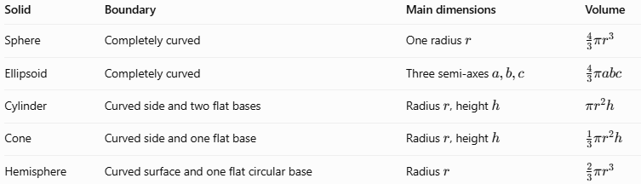
Solid | Boundary | Main dimensions | Volume
Sphere | Completely curved | One radius $r$ | $$\frac{4}{3}πr^{3}$$
Ellipsoid | Completely curved | Three semi-axes $a,b,c$ | $$\frac{4}{3}πabc$$
Cylinder | Curved side and two flat bases | Radius $r$, height $h$ | $$πr^{2}h$$
Cone | Curved side and one flat base | Radius $r$, height $h$ | $$\frac{1}{3}πr^{2}h$$
Hemisphere | Curved surface and one flat circular base | Radius $r$ | $$\frac{2}{3}πr^{3}$$
The key distinction is that a sphere has the same radius in every direction from its center, while an ellipsoid can have different dimensions along its three principal axes.

Applications of Ellipsoids
# Source: AI Source: Provided by: [Data Path: Persons Table -> ID Column: 1, Name_En Column: Motasem Essam] -> From: [ChatGPT] on [7/25/2026]
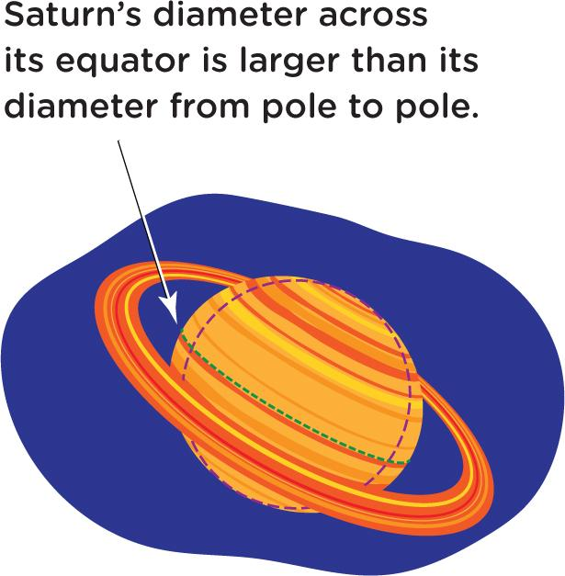
Astronomy
Planets can be approximated by oblate spheroids because rotation causes their equatorial dimensions to exceed their polar dimensions.
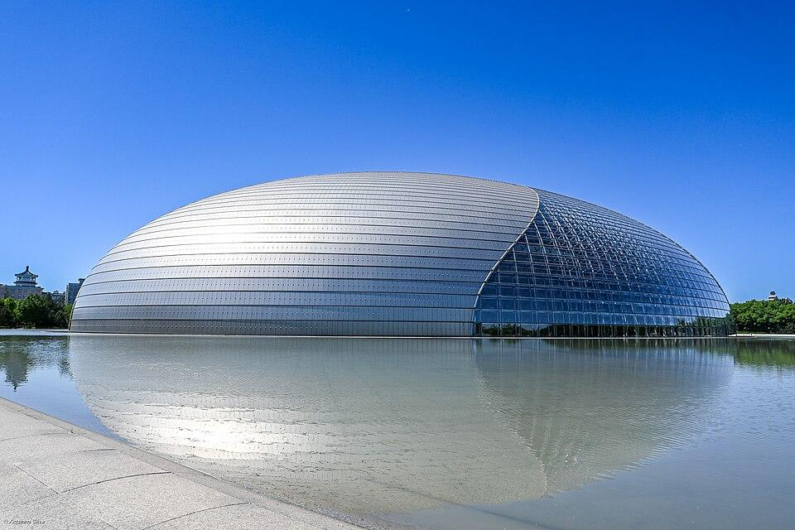
Architecture and engineering
Ellipsoidal forms are used in domes, structural components, and enclosure designs.
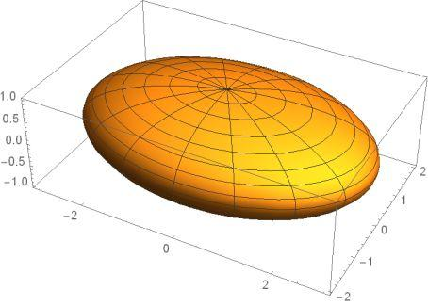
Medicine and biology
Ellipsoids can approximate the shapes and volumes of certain organs, cells, and other biological structures.
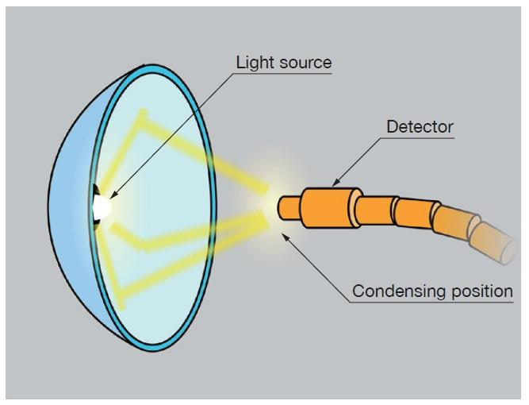
Optics and physics
Ellipsoidal reflectors and ellipsoidal mathematical models help describe the behavior of light and other physical systems.

Key Points
# Source: AI Source: Provided by: [Data Path: Persons Table -> ID Column: 1, Name_En Column: Motasem Essam] -> From: [ChatGPT] on [7/25/2026]
- An ellipsoid is a three-dimensional solid with a closed curved surface.
- It has three positive semi-axis lengths, $a$, $b$, and $c$.
- Its volume is $\frac{4}{3}πabc$.
- A sphere is a special ellipsoid with all three semi-axes equal.
- Prolate spheroids are elongated; oblate spheroids are flattened.
- A triaxial ellipsoid has three unequal semi-axes.
- An ellipsoid has no flat faces, straight edges, or vertices.
- Its general surface area requires an exact advanced formula or a suitable approximation.

Conclusion
# Source: AI Source: Provided by: [Data Path: Persons Table -> ID Column: 1, Name_En Column: Motasem Essam] -> From: [ChatGPT] on [7/25/2026]
An ellipsoid is an important solid in solid geometry because it generalizes the sphere by allowing three different principal dimensions. Its variations include elongated, flattened, and fully triaxial shapes. Understanding the semi-axes, standard equation, and volume formula makes it possible to classify ellipsoids and solve many geometric problems involving curved solids.

